**Shopping Behaviours Analysis**

**About Dataset**

[**https://www.kaggle.com/datasets/zubairamuti/shopping-behaviours-dataset?resource=download**](https://www.kaggle.com/datasets/zubairamuti/shopping-behaviours-dataset?resource=download)

**Context:**

This dataset provides detailed insights into **consumer behaviour and shopping patterns** across various demographics, locations, and product categories. It contains **3,900 customer records** with **18 attributes** that describe purchase details, shopping habits, and preferences.

The dataset includes information such as:

* **Customer demographics** (age, gender, location)
* **Product details** (item purchased, category, size, color, season)
* **Purchase information** (amount spent in USD, payment method, shipping type)
* **Shopping behaviour** (frequency of purchases, previous purchases, subscription status, discount usage, promo codes)
* **Customer feedback** (review ratings)

This dataset can be used to explore **consumer decision-making** and **market trends**, including:

* How age, gender, or location influence shopping preferences.
* The relationship between discounts, promo codes, and purchase amounts.
* Which product categories and colors are most popular in different seasons.
* Patterns in payment method usage (e.g., PayPal vs. Credit Card).
* How subscription and loyalty behaviours affect shopping frequency.

Researchers, data analysts, and students can use this dataset to practice **customer segmentation, predictive modelling, recommendation systems, and market basket analysis**. It also serves as a valuable resource for learning techniques in **exploratory data analysis (EDA)**, **machine learning**, and **business analytics**.

**Dataset Glossary (Column wise)**

**Customer ID:**

* A unique identifier assigned to each customer.
* It helps distinguish one shopper’s data from another without revealing their personal identity.

**Age:**

* The age of the customer in years, which can provide insights into generational shopping habits and how preferences differ across age groups.

**Gender:**

* Indicates whether the customer is male or female, allowing analysis of gender-based buying trends and preferences in product categories.

**Item Purchased:**

* The specific product that the customer bought, giving a direct view of consumer demand and popular items in the dataset.

**Category:**

* The broader classification of the purchased item, such as clothing or footwear, which helps in grouping products and understanding category-level trends.

**Purchase Amount (USD):**

* The total money spent on the purchase in U.S. dollars, which reflects customer spending power and the value of each transaction.

**Location:**

* The state or region where the customer resides, useful for identifying geographical shopping patterns and regional differences in consumer behaviour.

**Size:**

* The size of the purchased item (e.g., S, M, L), which helps reveal customer preferences in apparel and how sizing impacts sales.

**Color:**

* The chosen color of the purchased item, offering insights into which colors are more appealing to consumers during different seasons or product categories.

**Season:**

* The season (Winter, Spring, etc.) in which the purchase was made, showing how customer demand changes across seasonal trends.

**Review Rating:**

* A numerical score reflecting the customer’s satisfaction with the product, valuable for measuring quality perception and post-purchase behaviour.

**Subscription Status:**

* Indicates whether the customer has an active subscription with the store, which may influence loyalty, discounts, and purchase frequency.

**Shipping Type:**

* The delivery option chosen by the customer, such as free shipping or express, which highlights convenience preferences and urgency of purchase.

**Discount Applied:**

* Shows whether a discount was used during the purchase, allowing analysis of how discounts affect buying decisions and sales growth.

**Promo Code Used:**

* Specifies if the customer used a promotional code, useful for understanding the impact of marketing strategies on purchase behaviour.

**Previous Purchases:**

* The number of items the customer has bought before, reflecting their shopping history and overall loyalty to the store.

**Payment Method:**

* The mode of payment used (Credit Card, PayPal, etc.), which sheds light on financial behaviour and preferred transaction methods.

**Frequency of Purchases:**

* Indicates how often the customer engages in purchasing activities, a critical metric for assessing customer loyalty and lifetime value.

**Features Division on the Basis of Data Types**

|  |  |  |  |  |  |
| --- | --- | --- | --- | --- | --- |
| **Numerical / Quantitative** | | **Categorical / Qualitative** | | | |
| **Discrete** | **Continuous** | **Nominal** | **Ordinal** | **Binary** | **Textual / High-cardinality** |
| Age | Review Rating | Customer ID | Size | Subscription Status | Item Purchased |
| Previous Purchases | Purchase Amount (USD) | Gender | Frequency of Purchases | Discount Applied | Location |
|  |  | Category |  | Promo Code Used | Color |
| Season |  |  |
| Shipping Type |
| Payment Method |

**Data in Numerical Features:**

* Age: 18 to 70
* Purchase Amount (USD): 20 to 100 USD
* Review Rating: 2.5 to 5.0
* Previous Purchases: 1 to 50

**Data in Categorical Features:**

* Gender: [Male, Female]
* Item Purchased: 25
* Category: [Clothing, Accessories, Footwear, Outerwear]
* Location: 50
* Size: [S, M, L, XL]
* Color: 25
* Season: [Spring, Fall, Winter, Summer]
* Subscription Status: [No, Yes]
* Shipping Type: [Free Shipping, Standard, Store Pickup, Next Day Air, Express, 2-Day Shipping]
* Discount Applied: [No, Yes]
* Promo Code Used: [No, Yes]
* Payment Method: [PayPal, Credit Card, Cash, Debit Card, Venmo, Bank Transfer]
* Frequency of Purchased: [Every 3 Months, Annually, Quarterly, Monthly, Bi-Weekly, Fortnightly, Weekly]

**Univariate Analysis (Numerical)**

* 1. Age

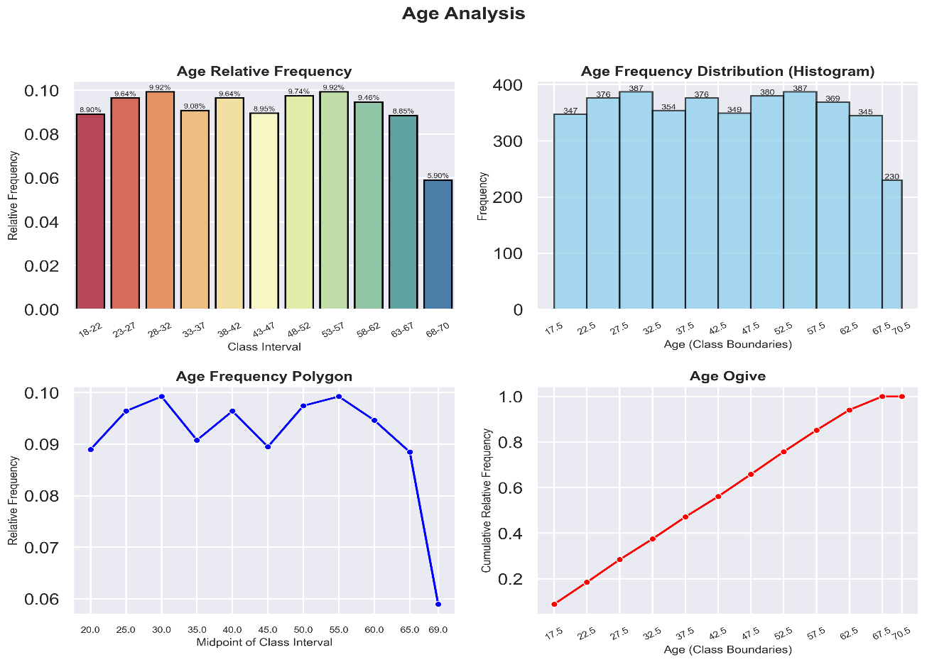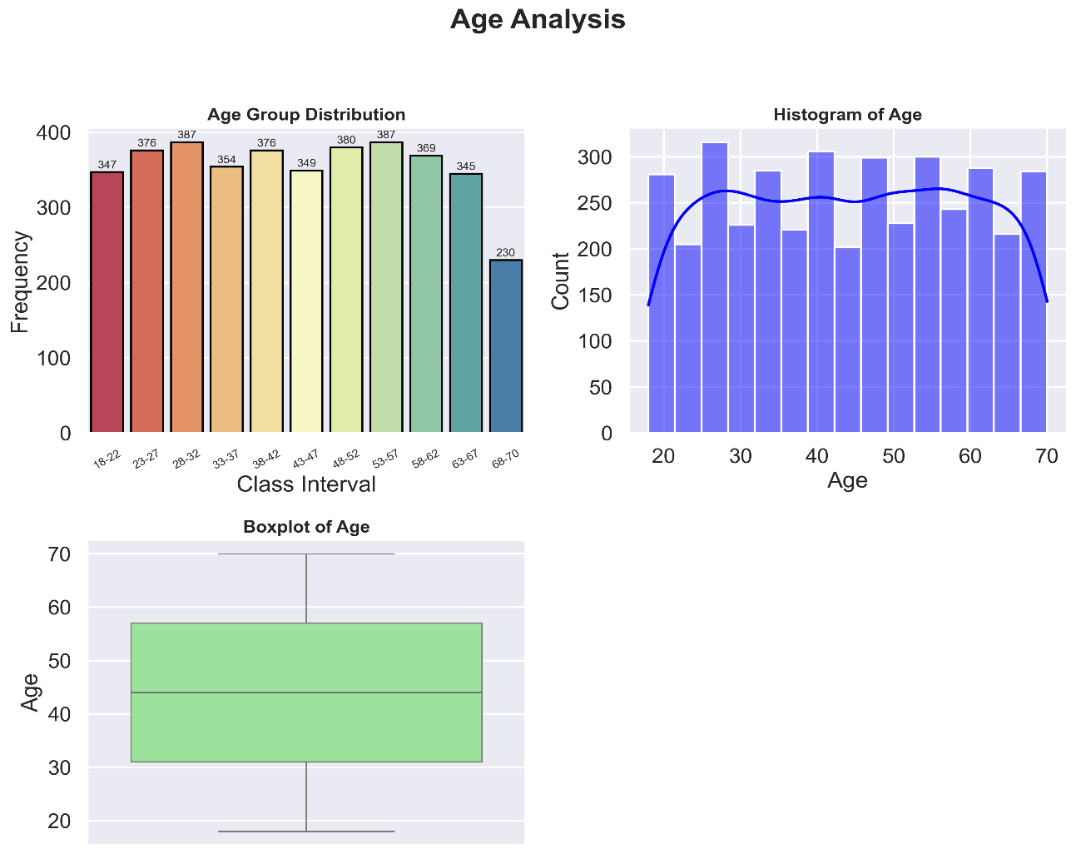

* 1. Purchase Amount (USD)

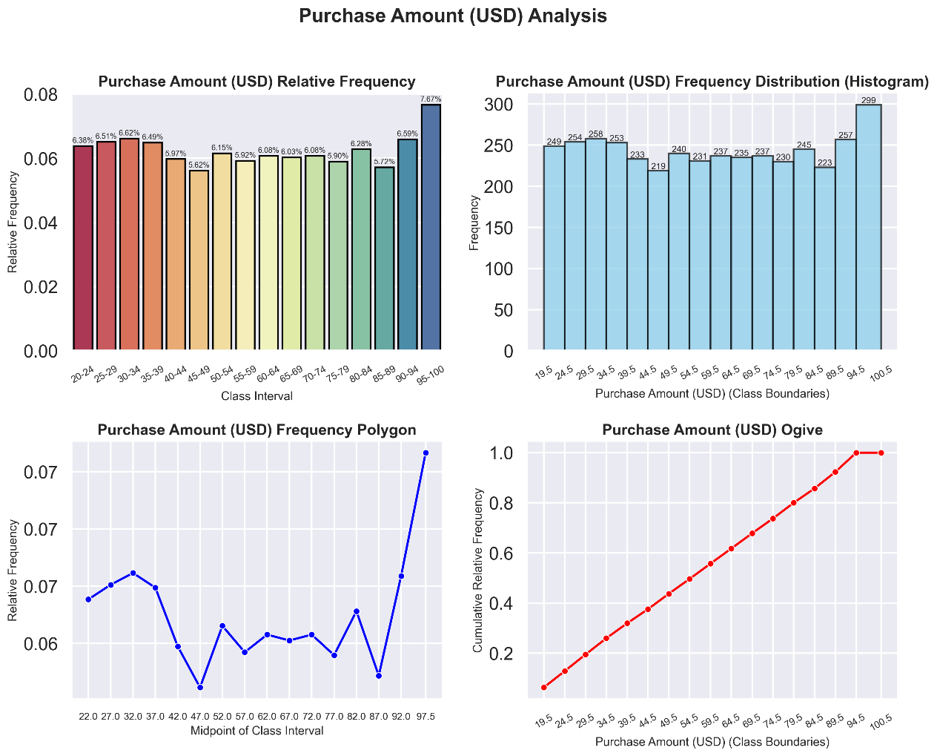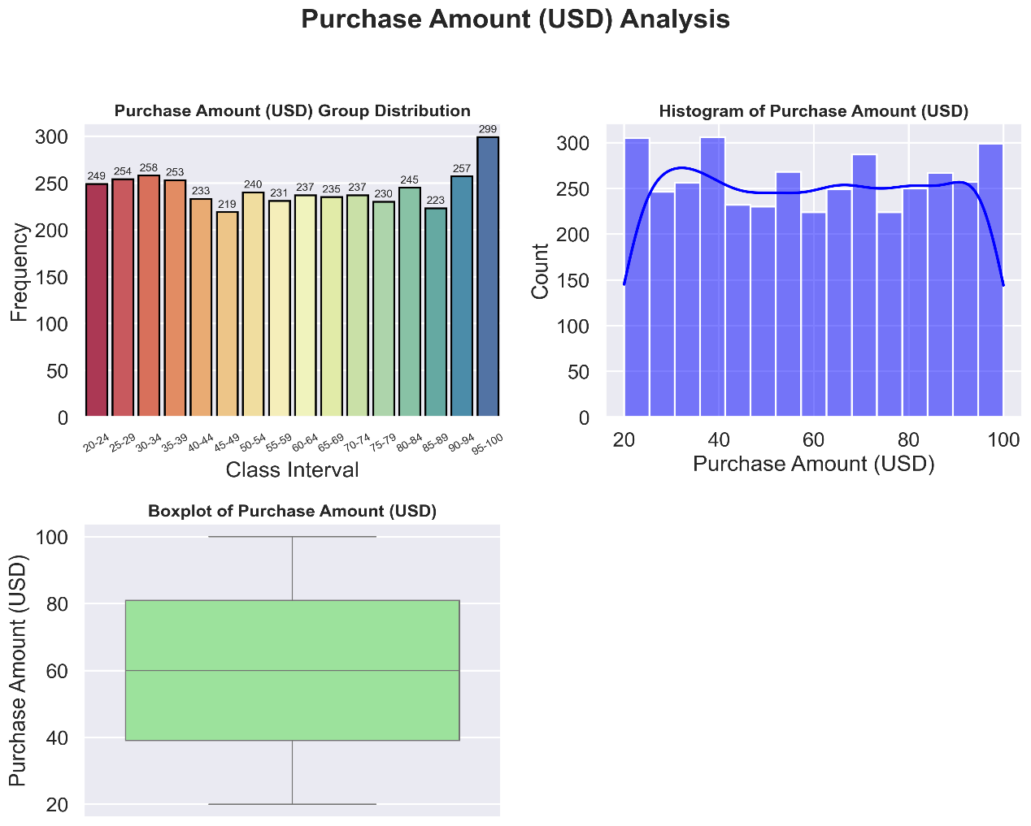

* 1. Review Rating

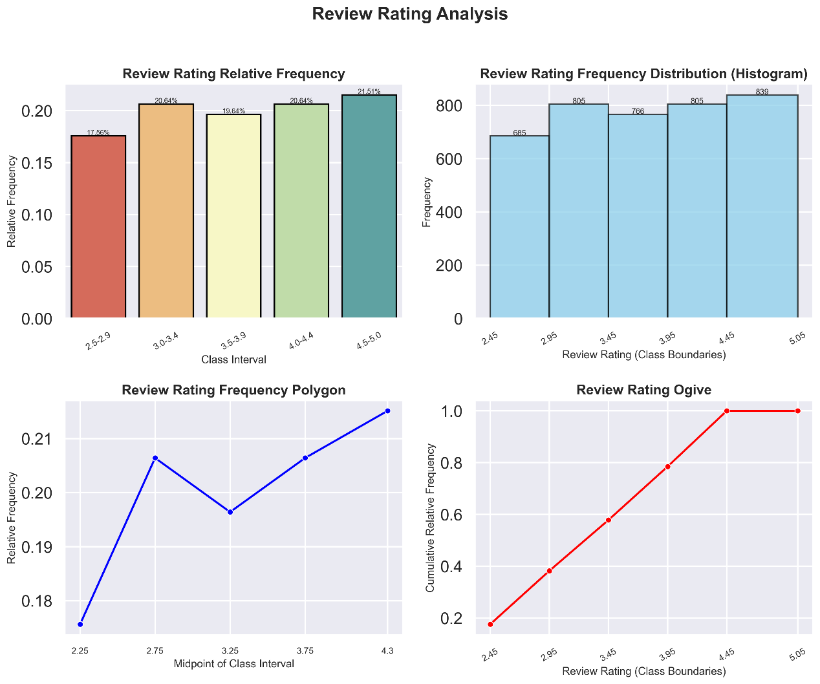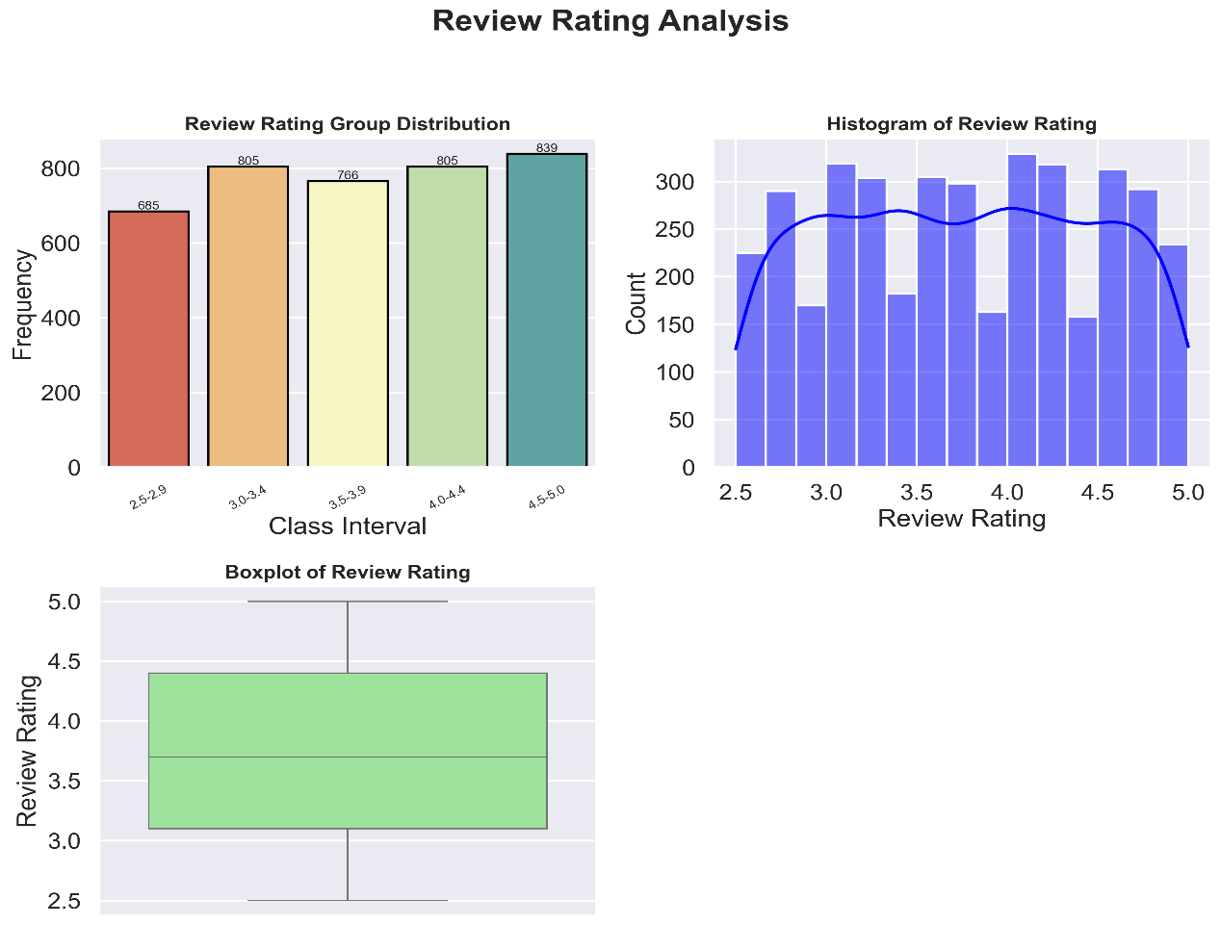

* 1. Previous Purchases

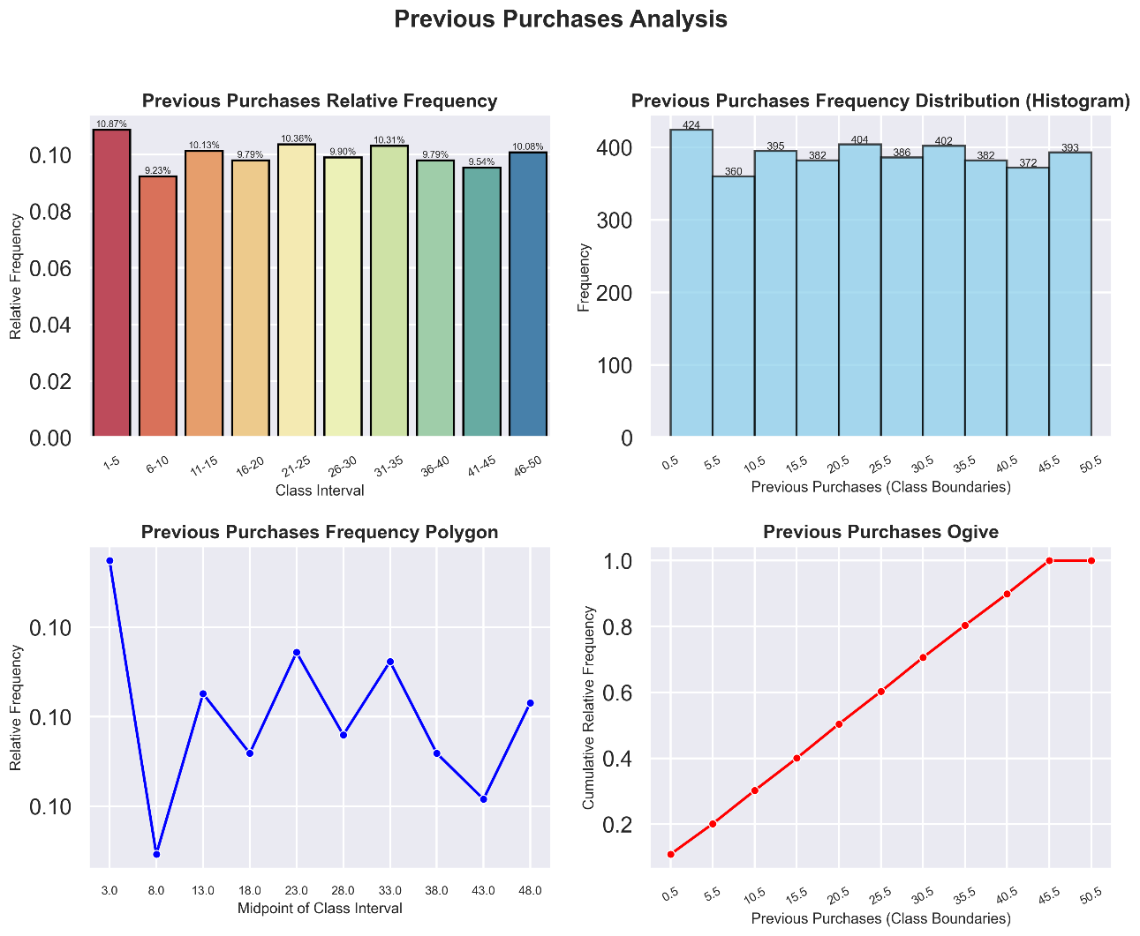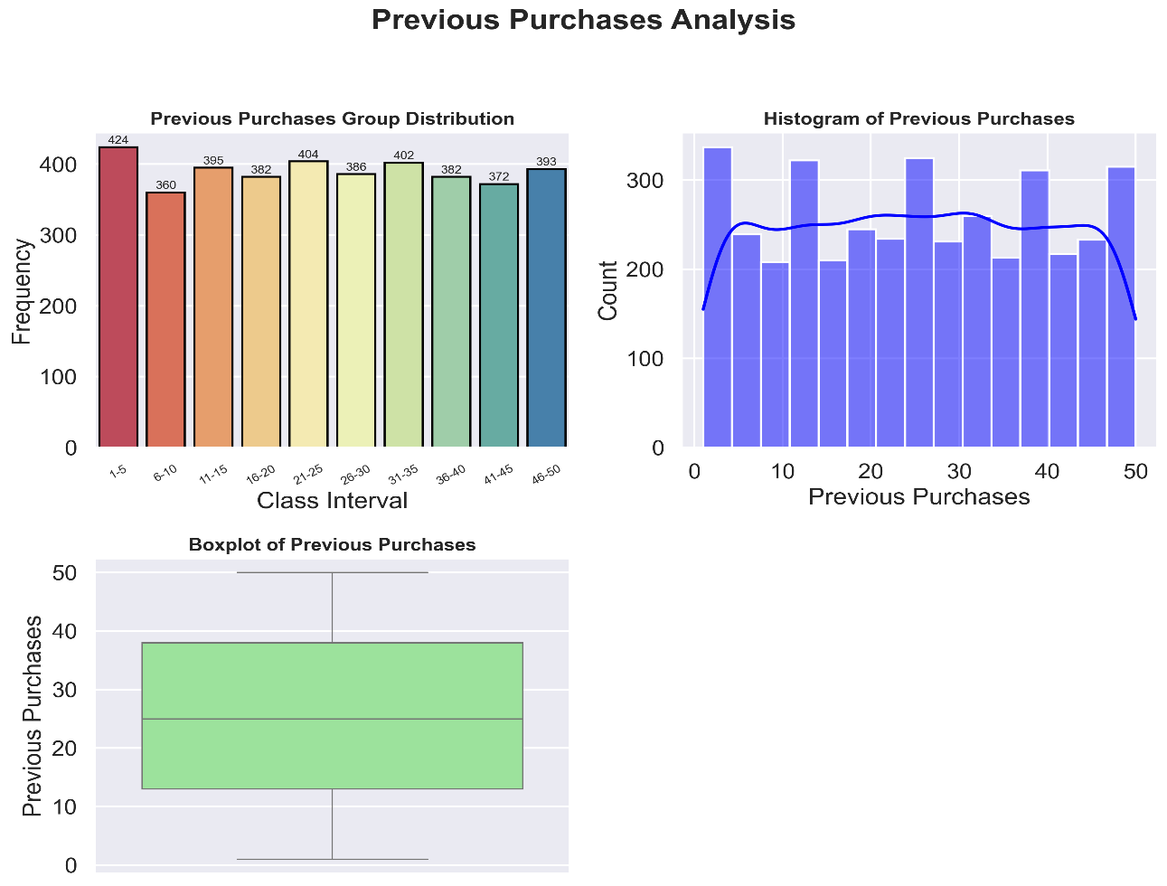

**Univariate Analysis (Categorical)**

1. Binary Classes: Gender + Subscription Status + Discount Applied + Promo Code Used

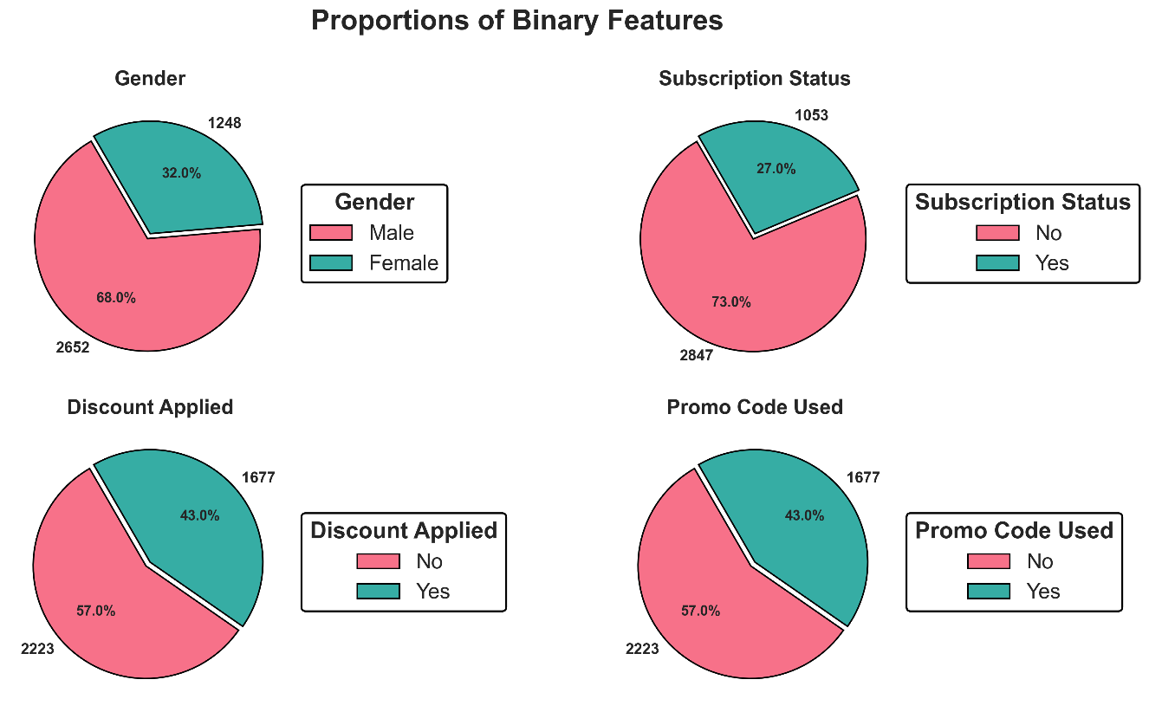

1. Quaternary Classes: Category + Size + Season

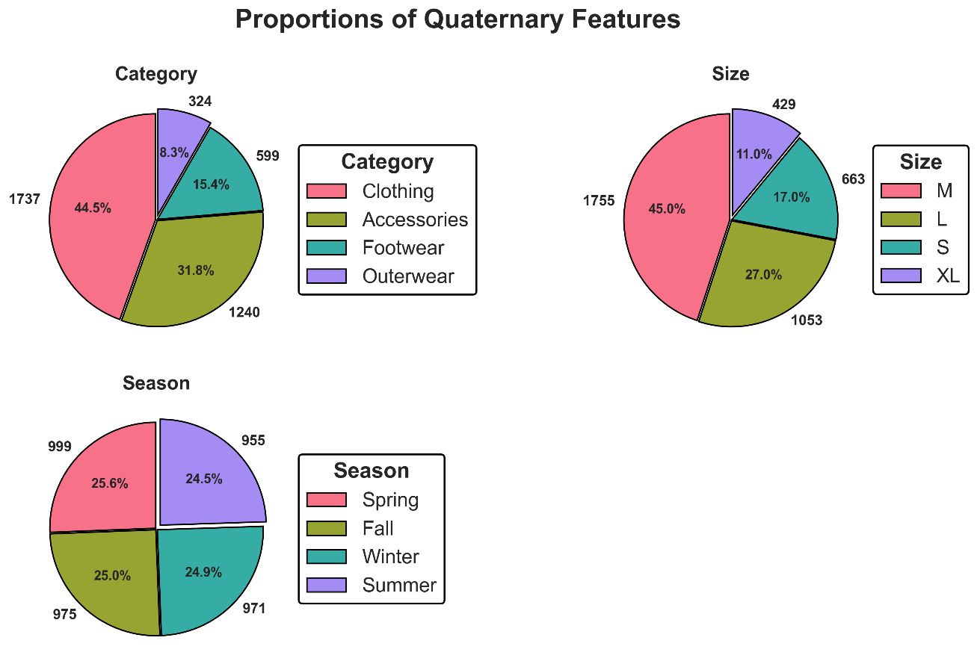

1. Senary Classes: Shipping Type + Payment Method + Frequency of Purchases

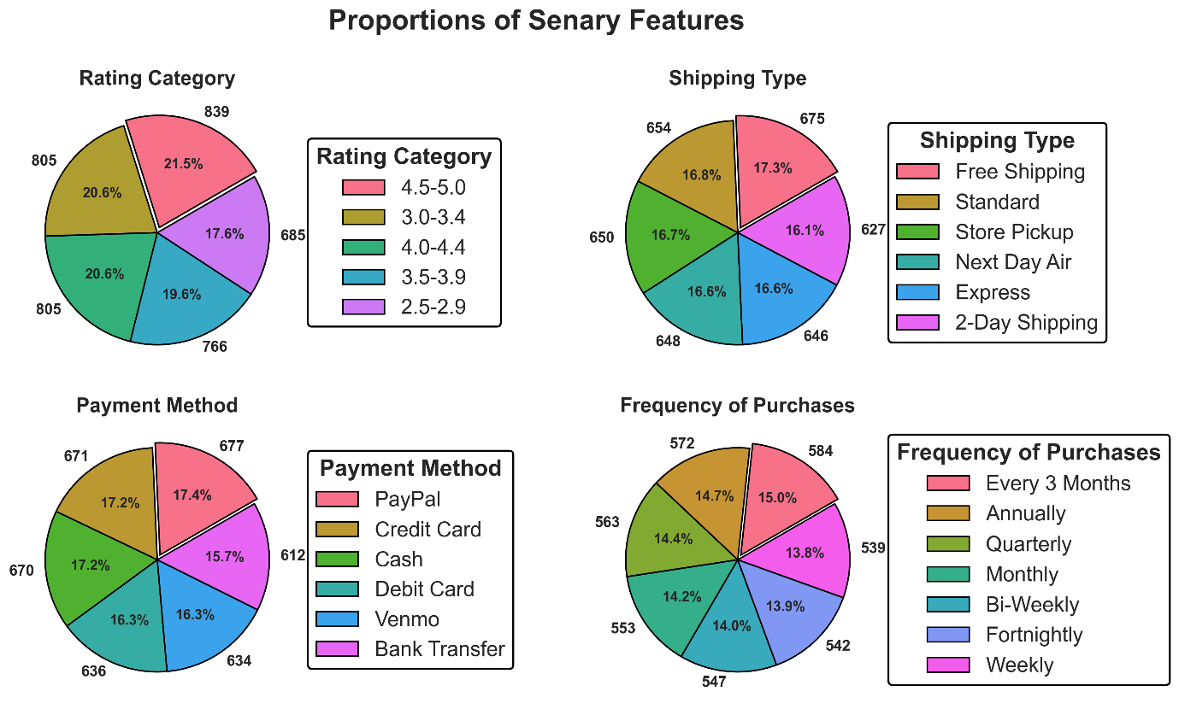

1. Item Purchased

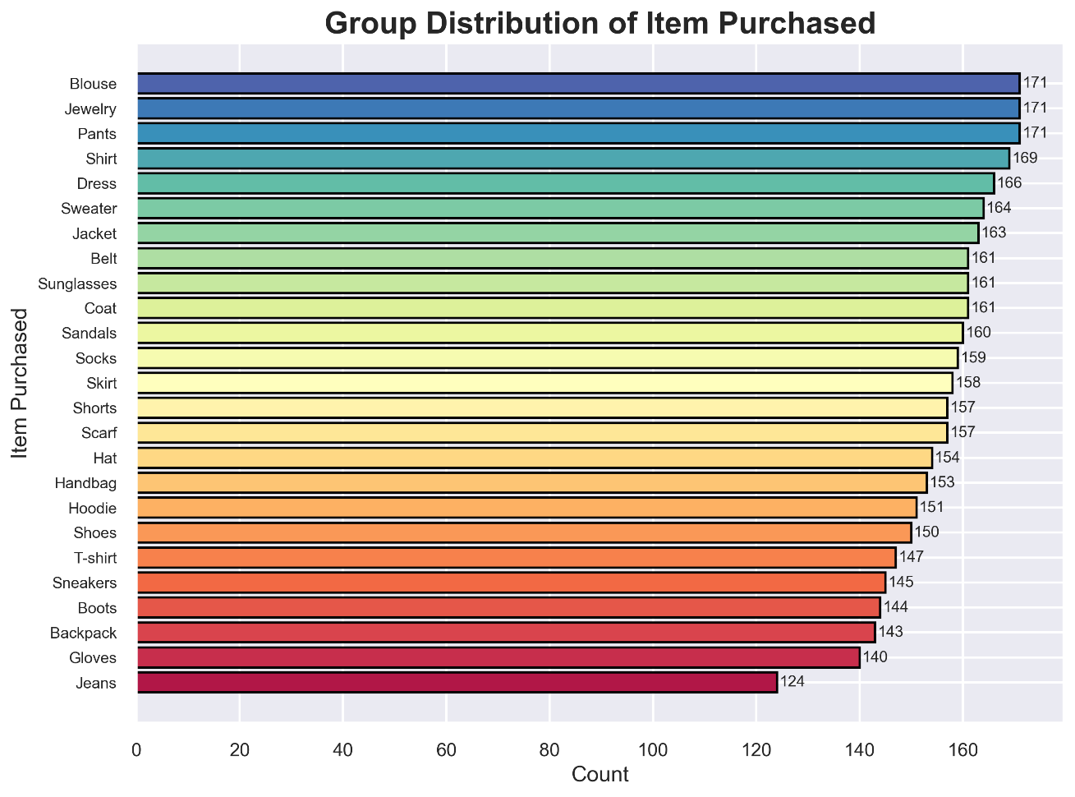

1. Color

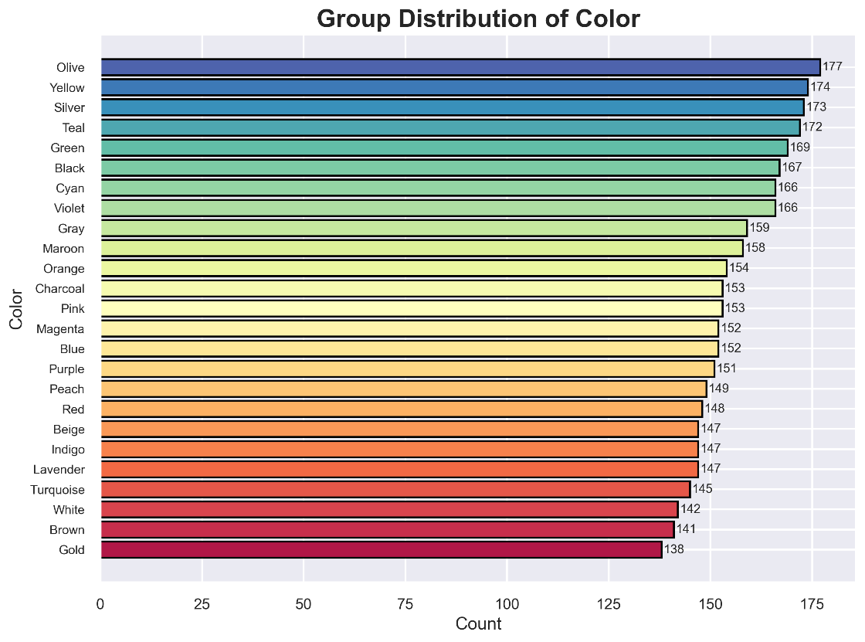

1. Location

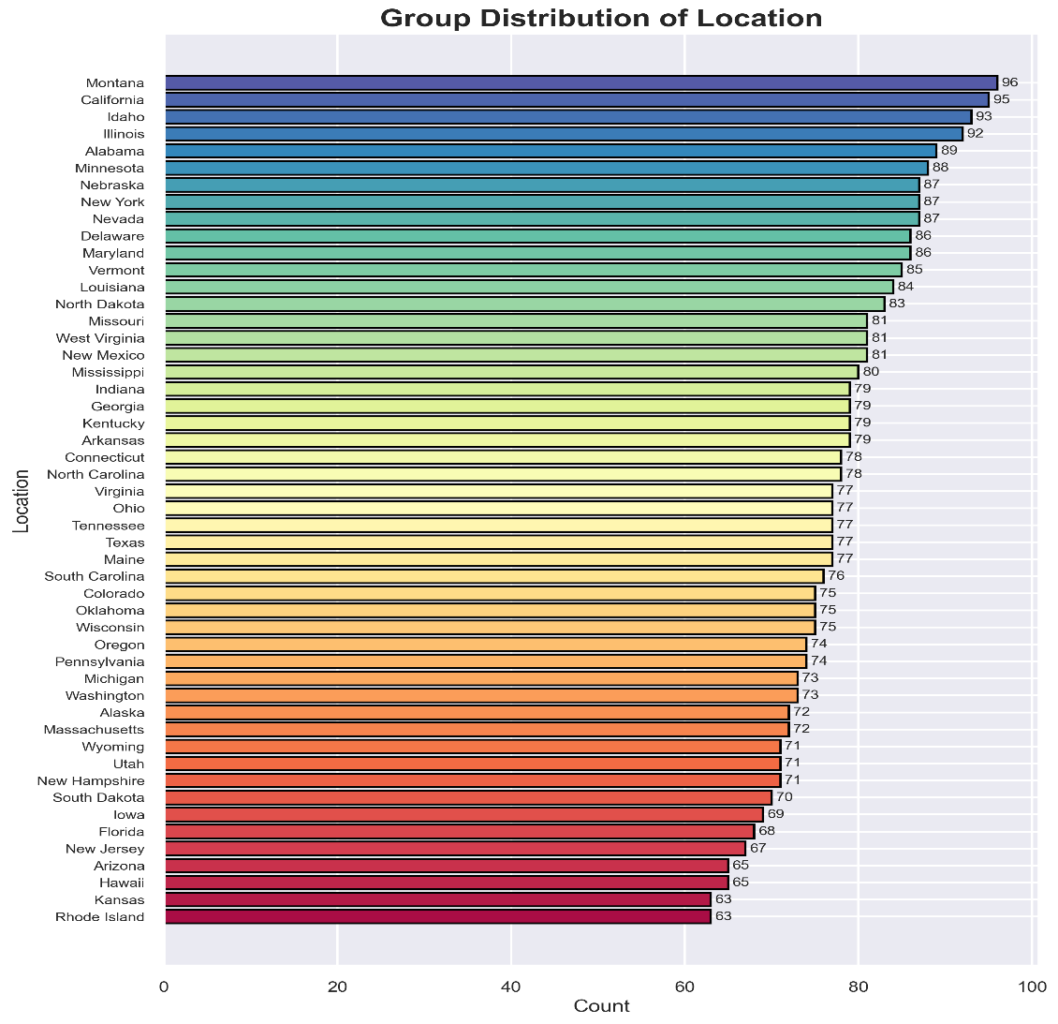

**Bivariate Analysis**

* **Numerical vs Numerical**

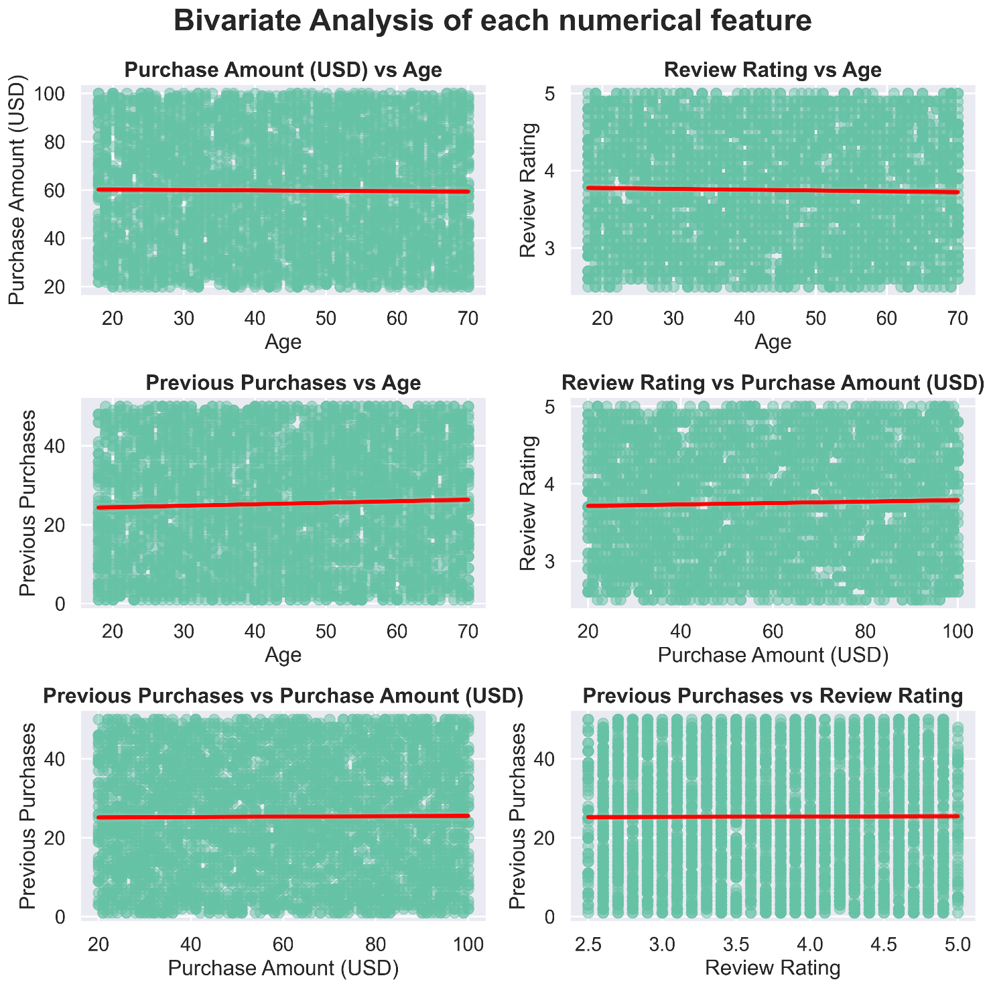

* **Categorical vs Categorical**

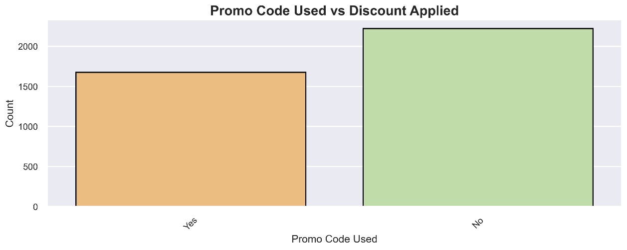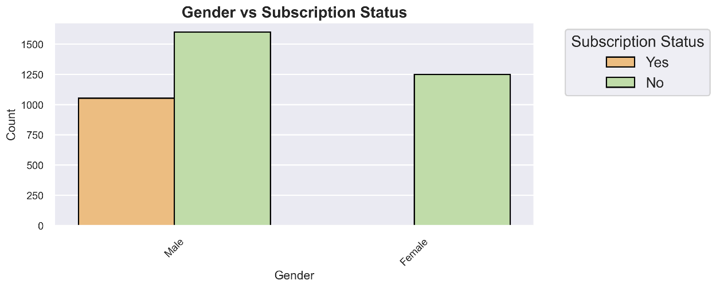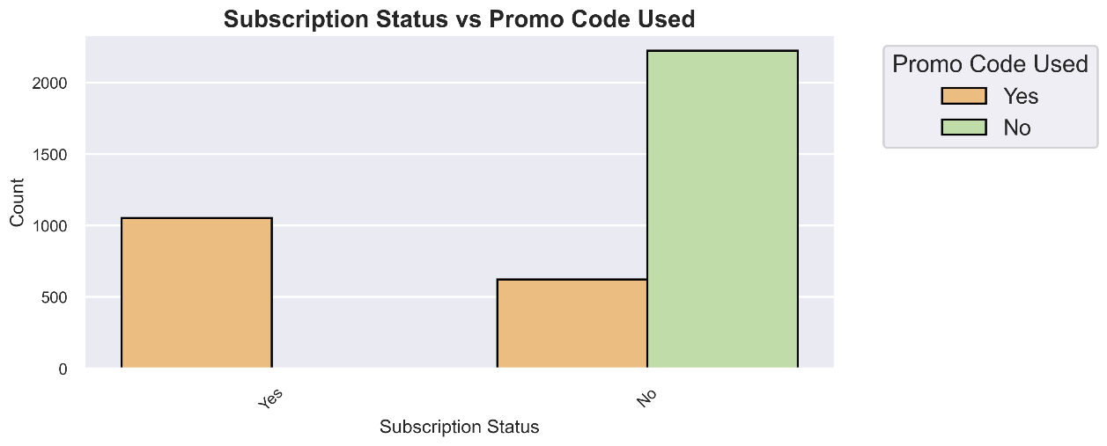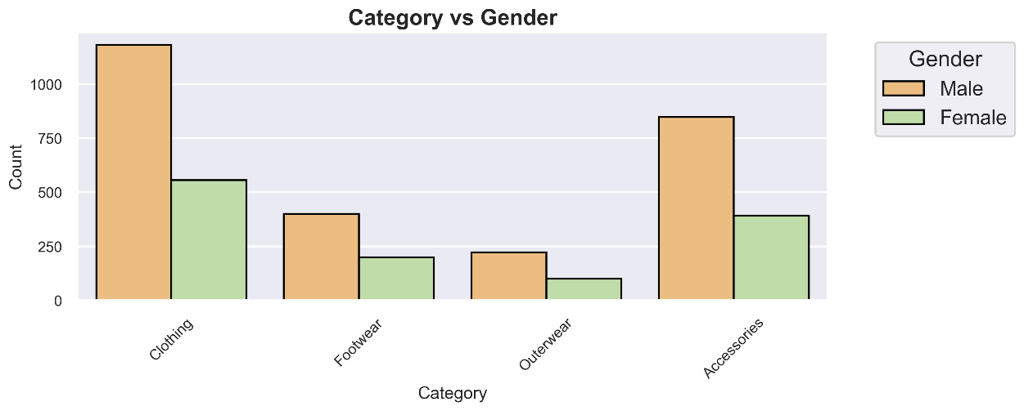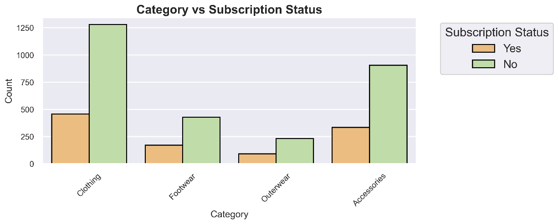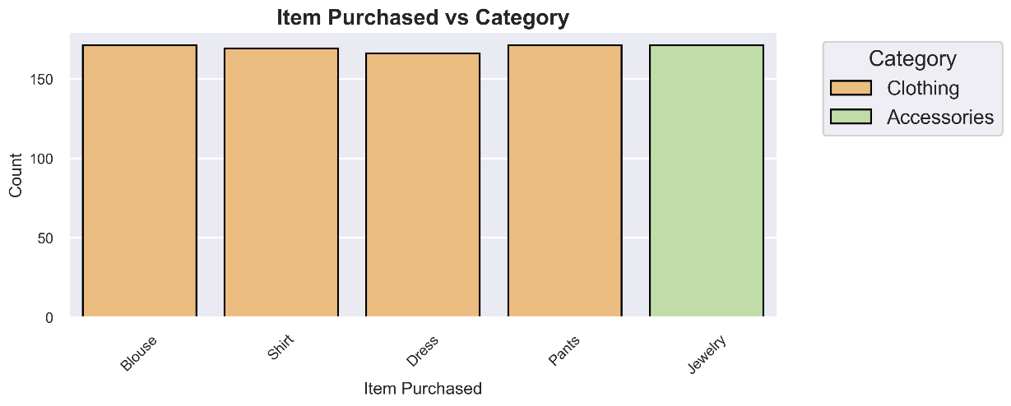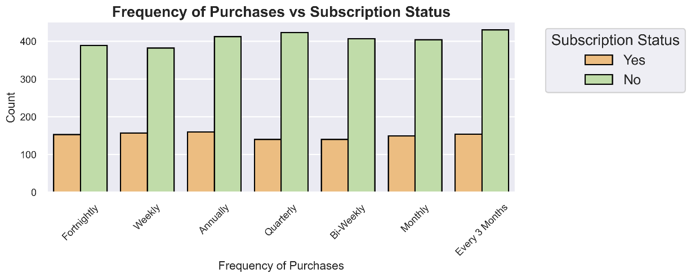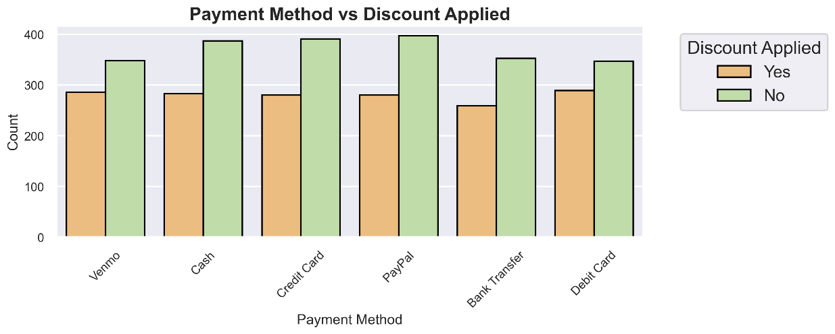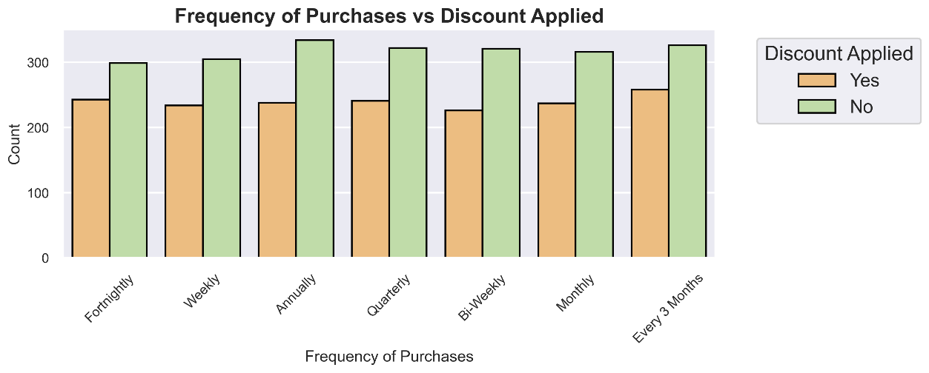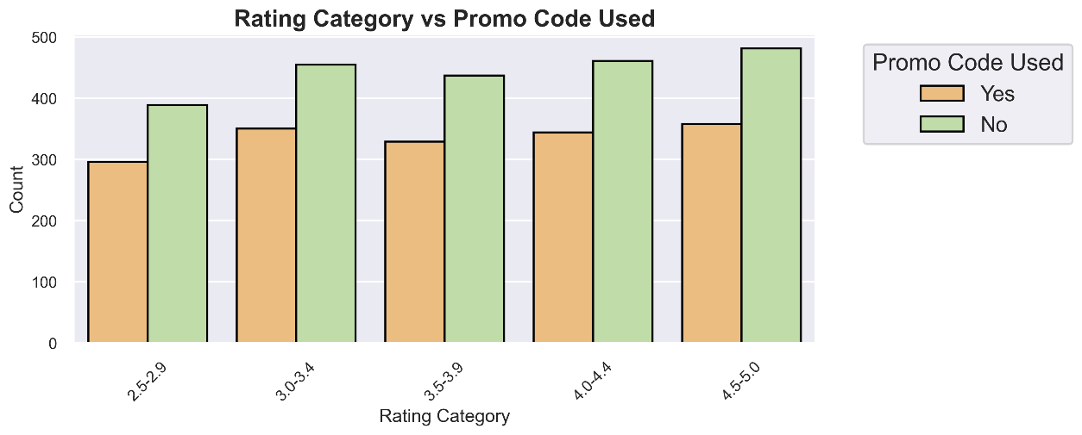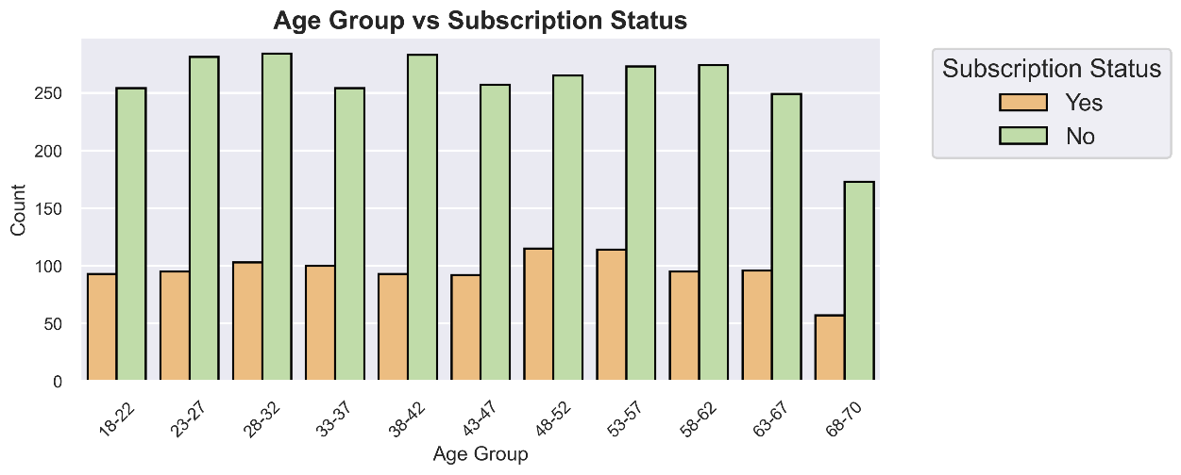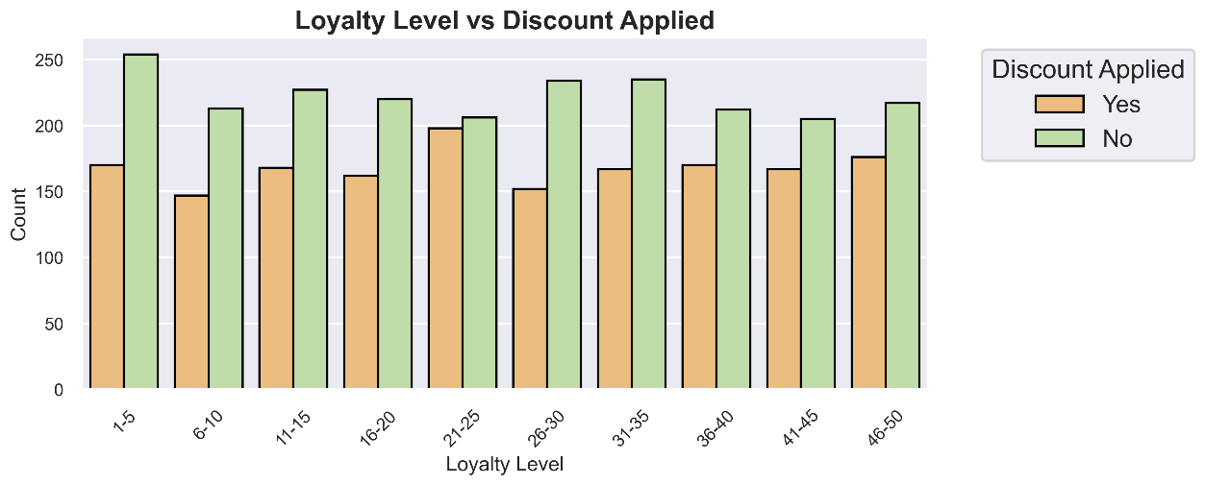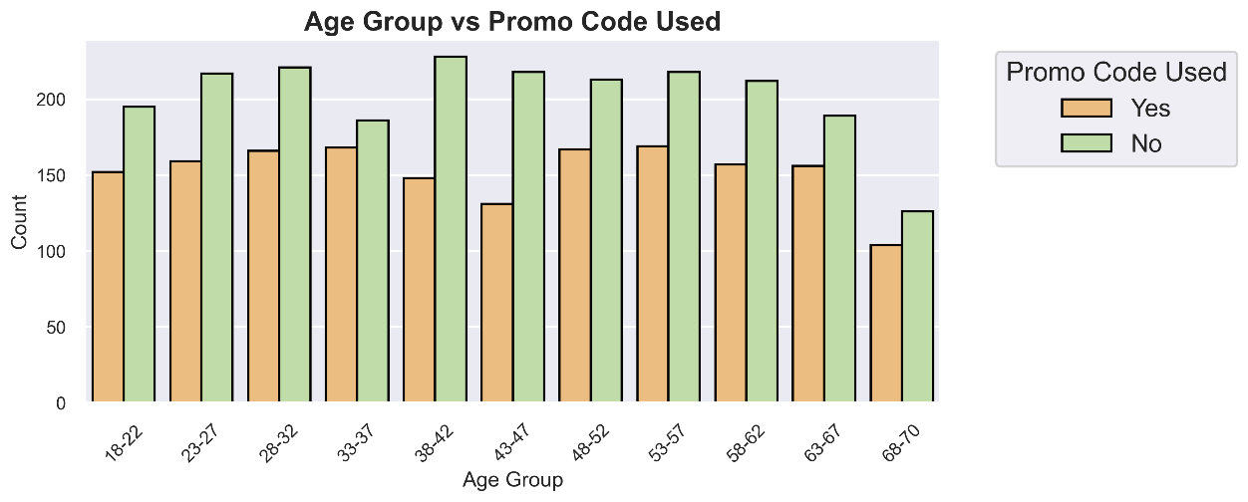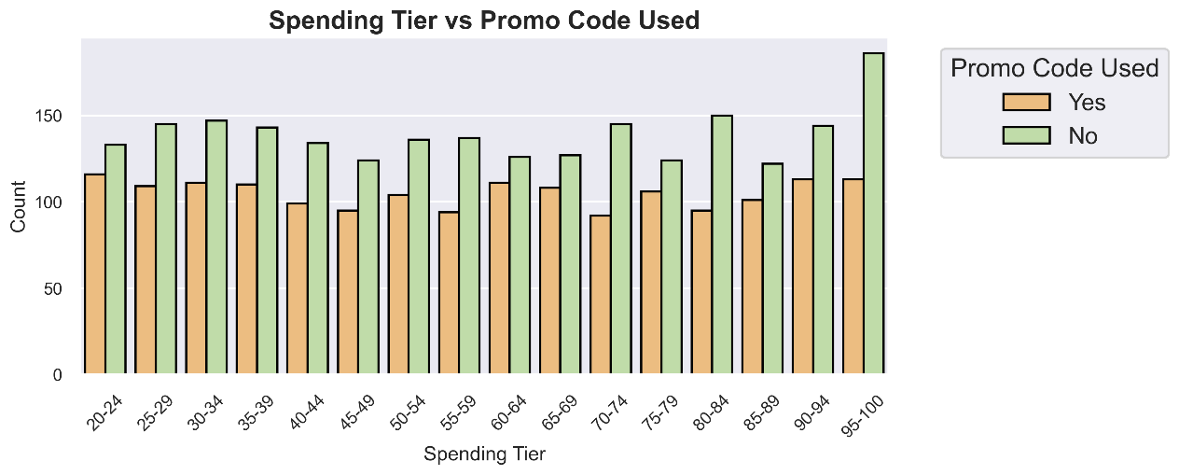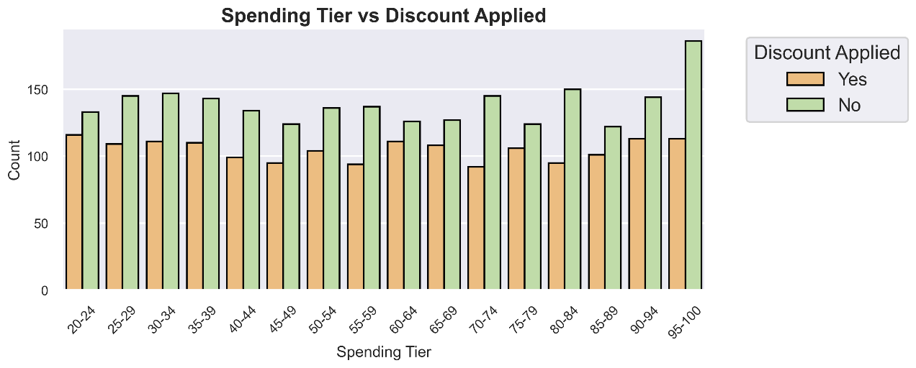

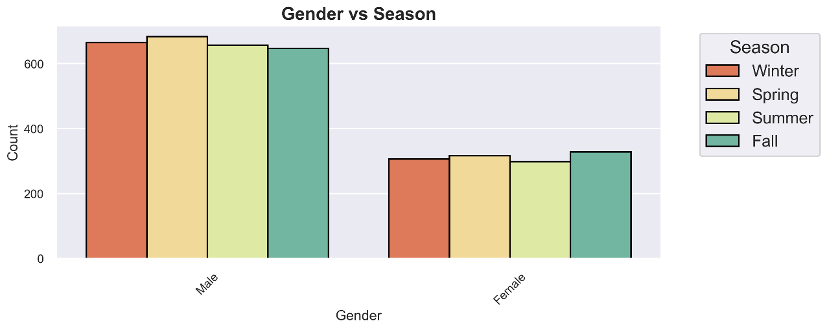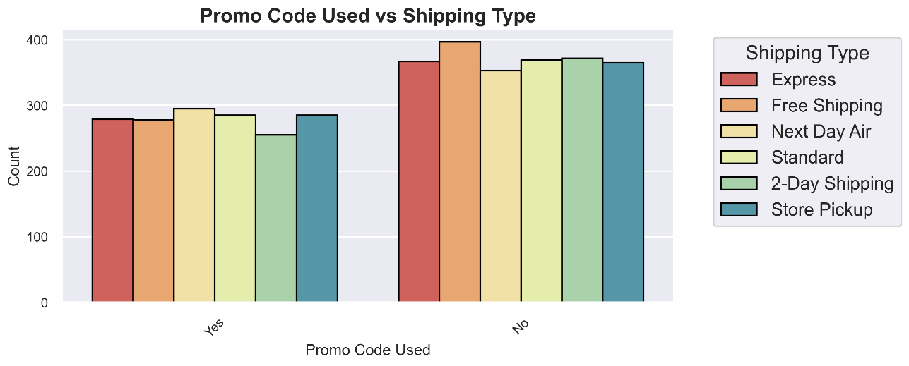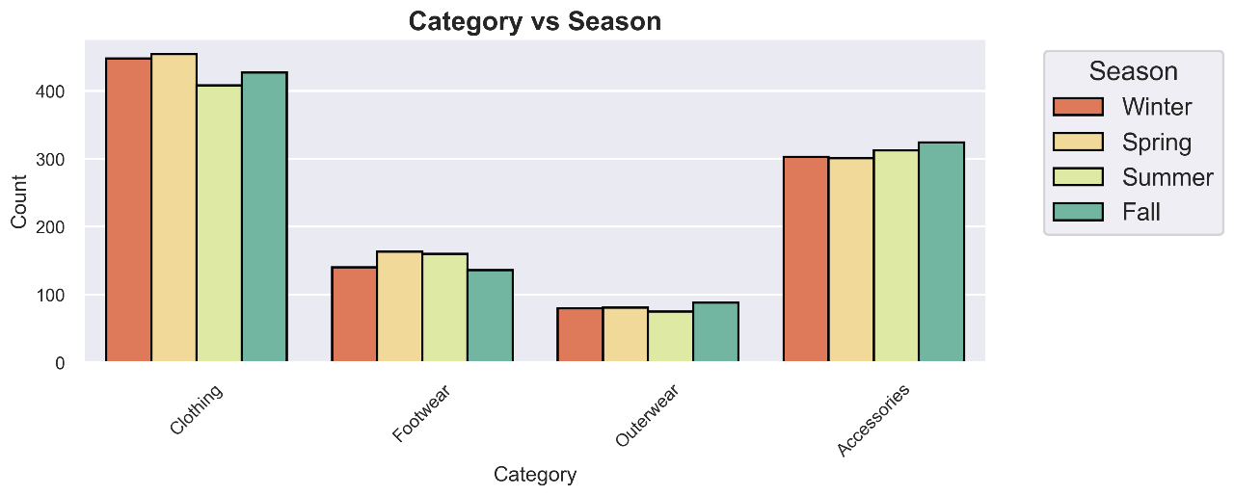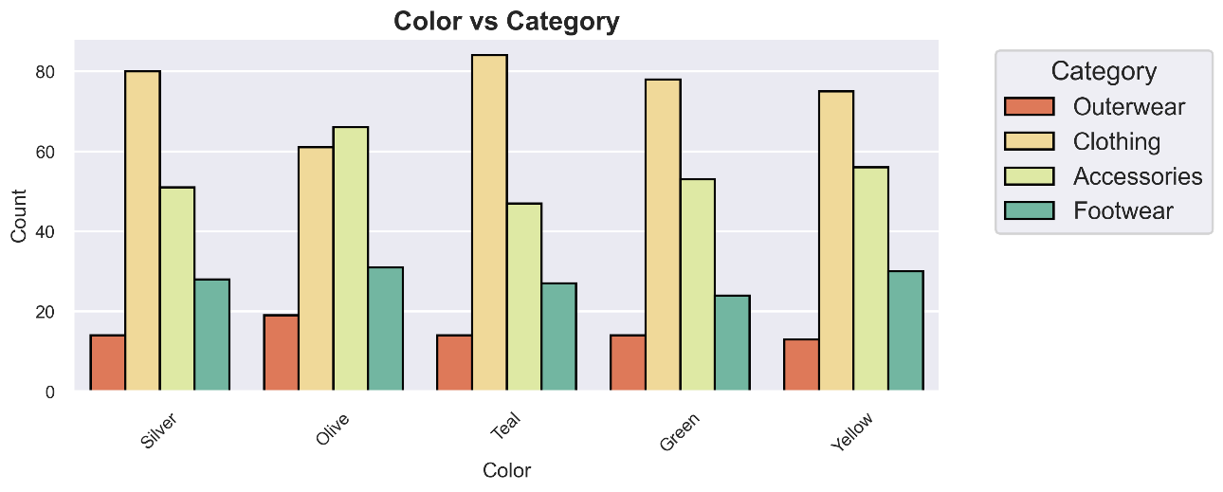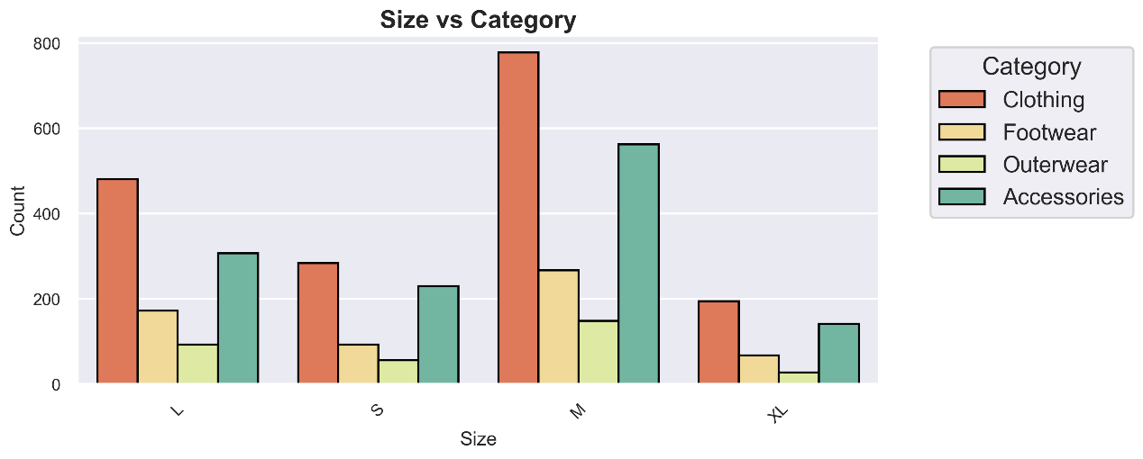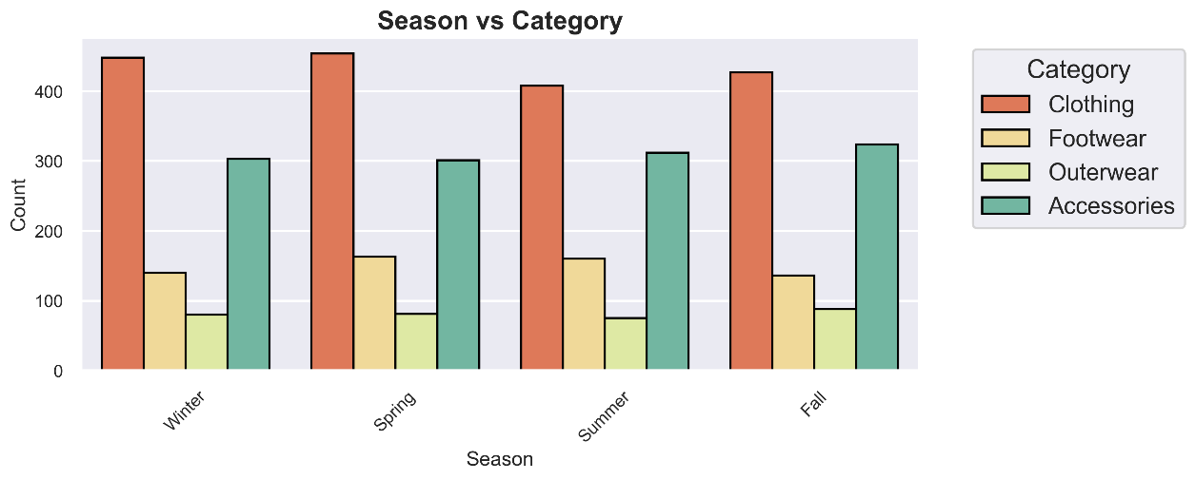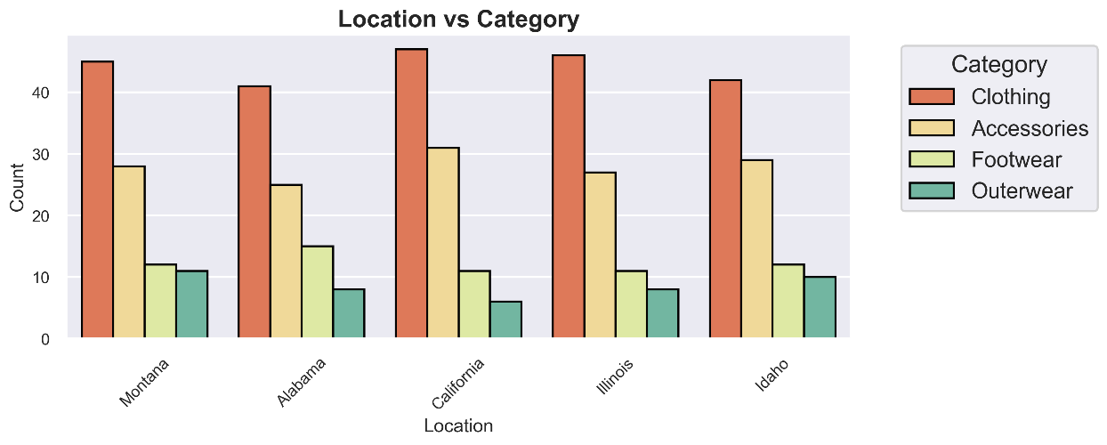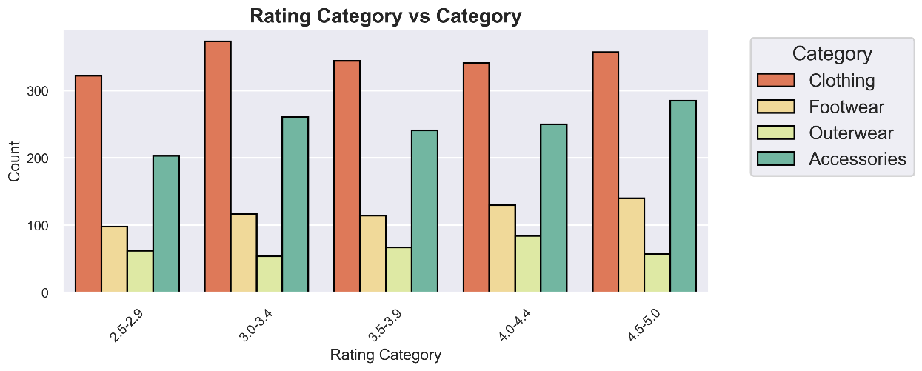

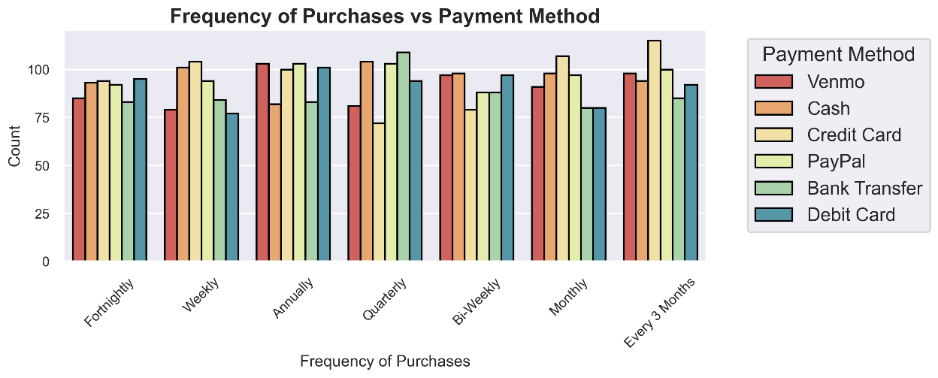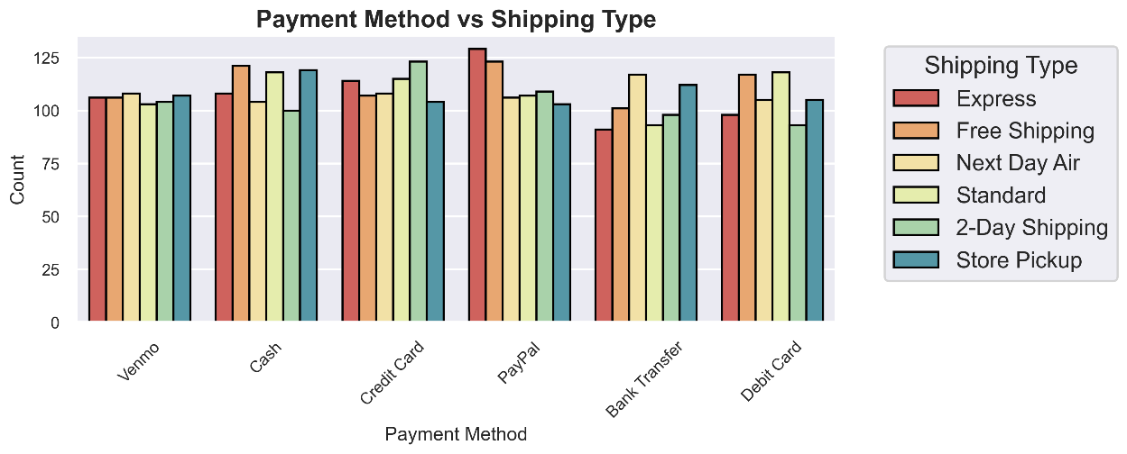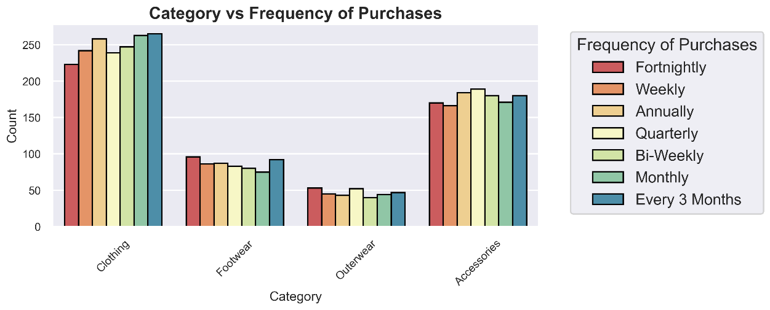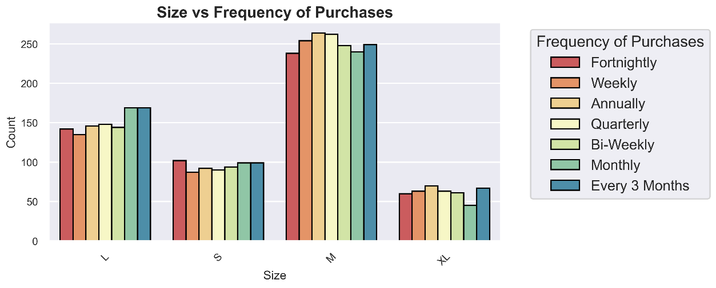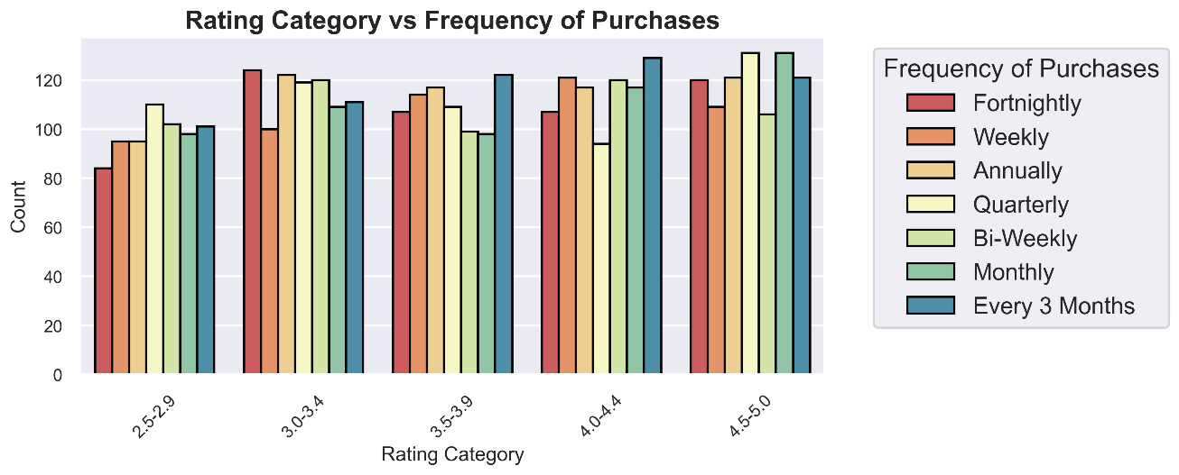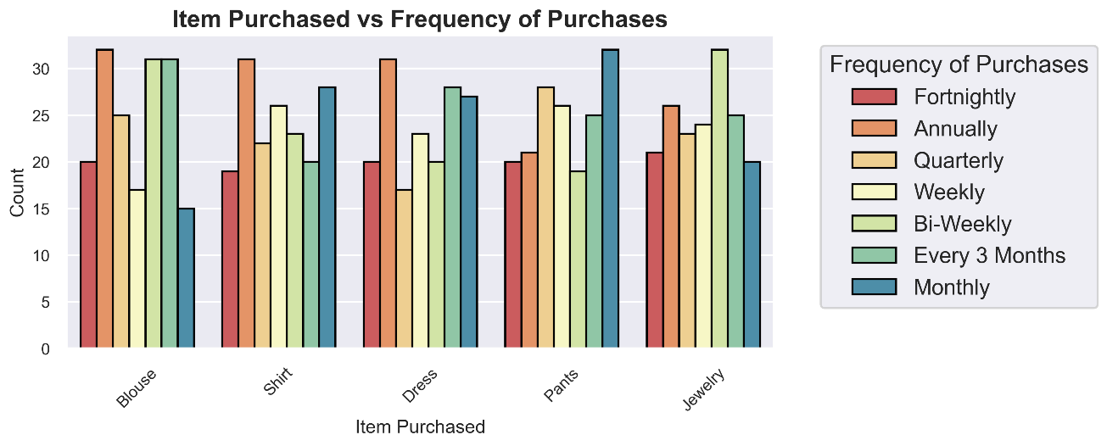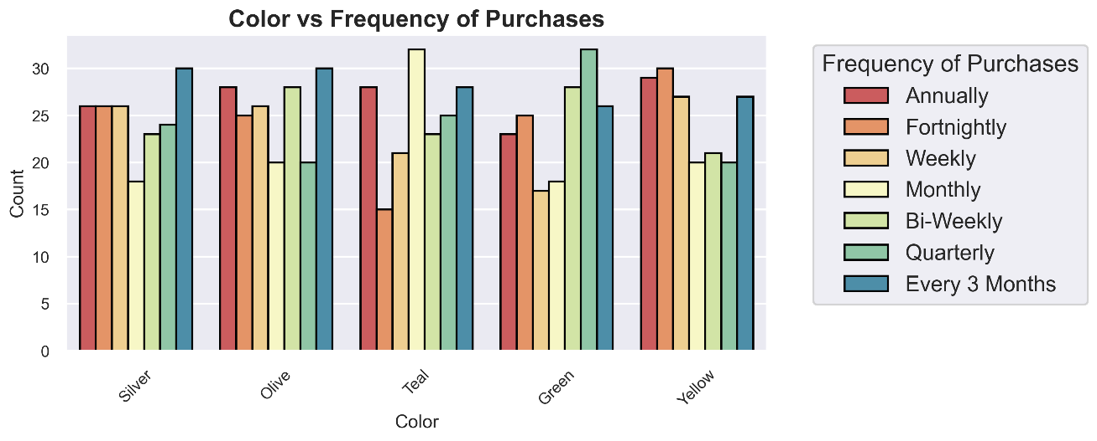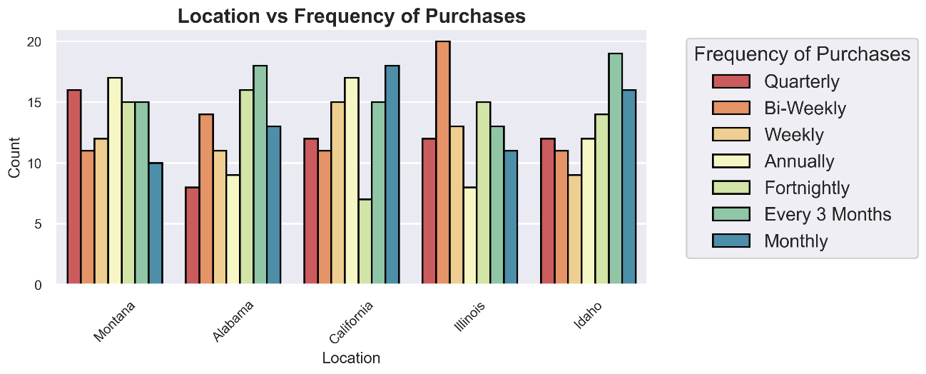

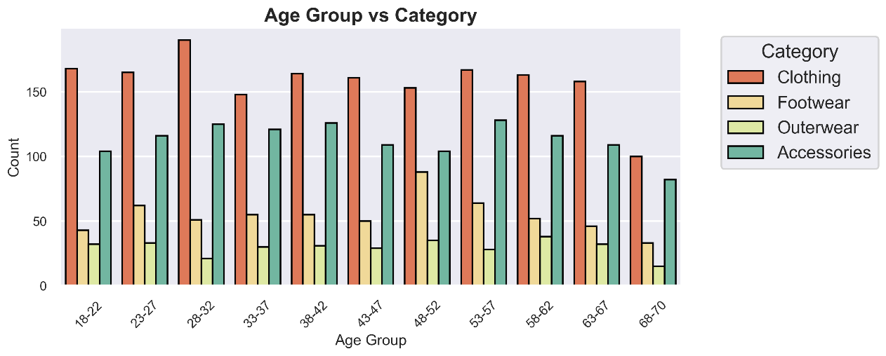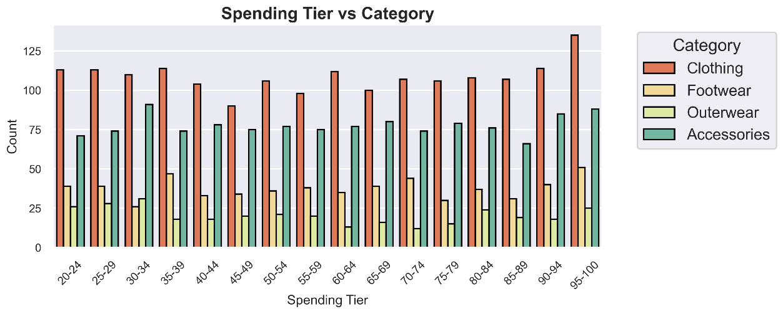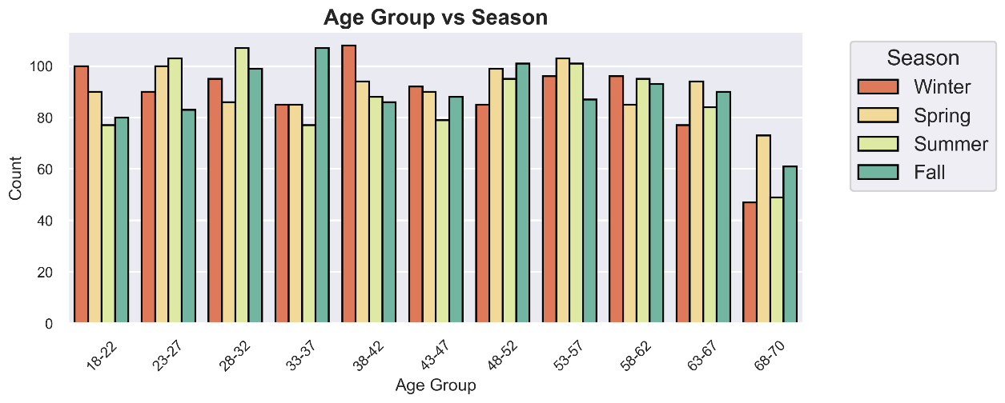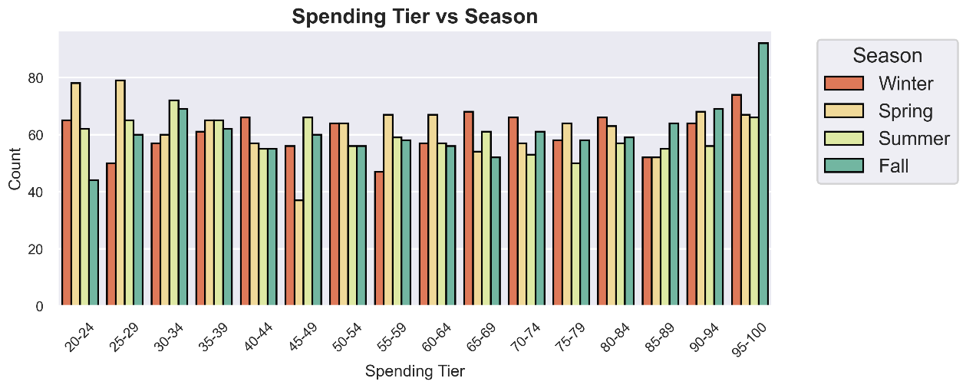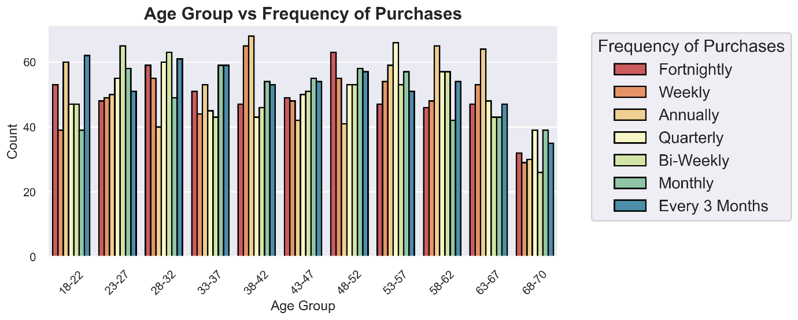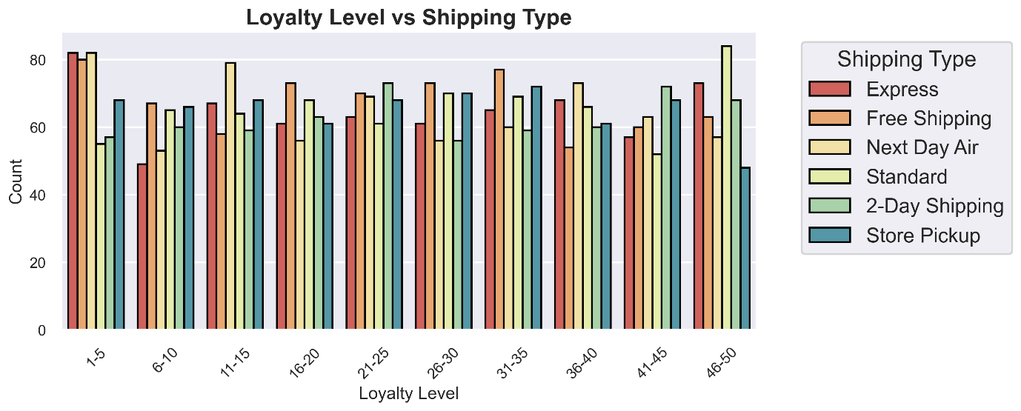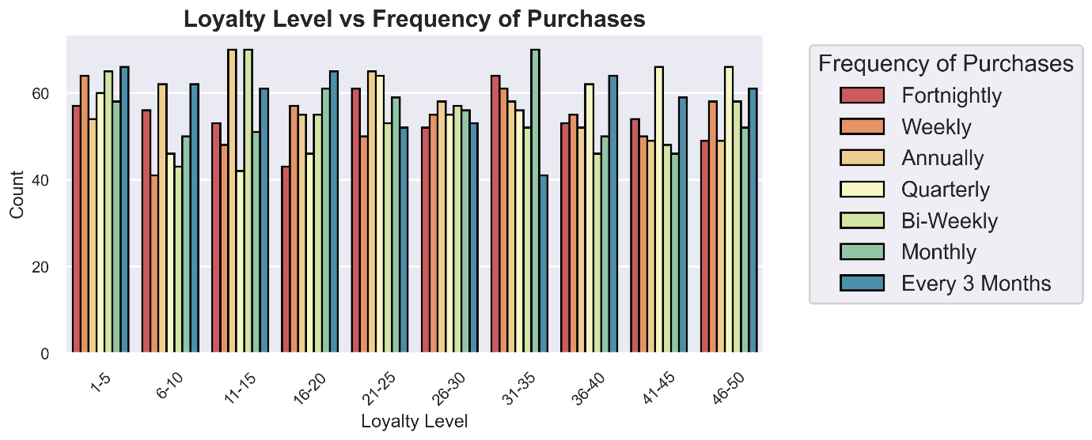

* **Numerical vs Categorical**

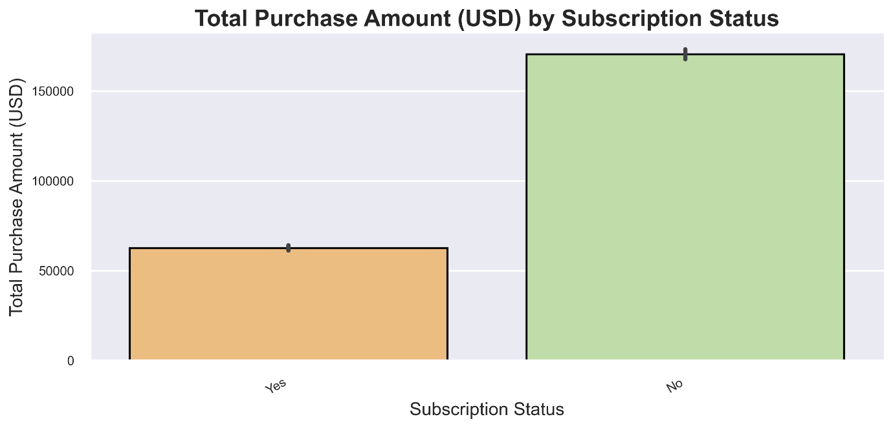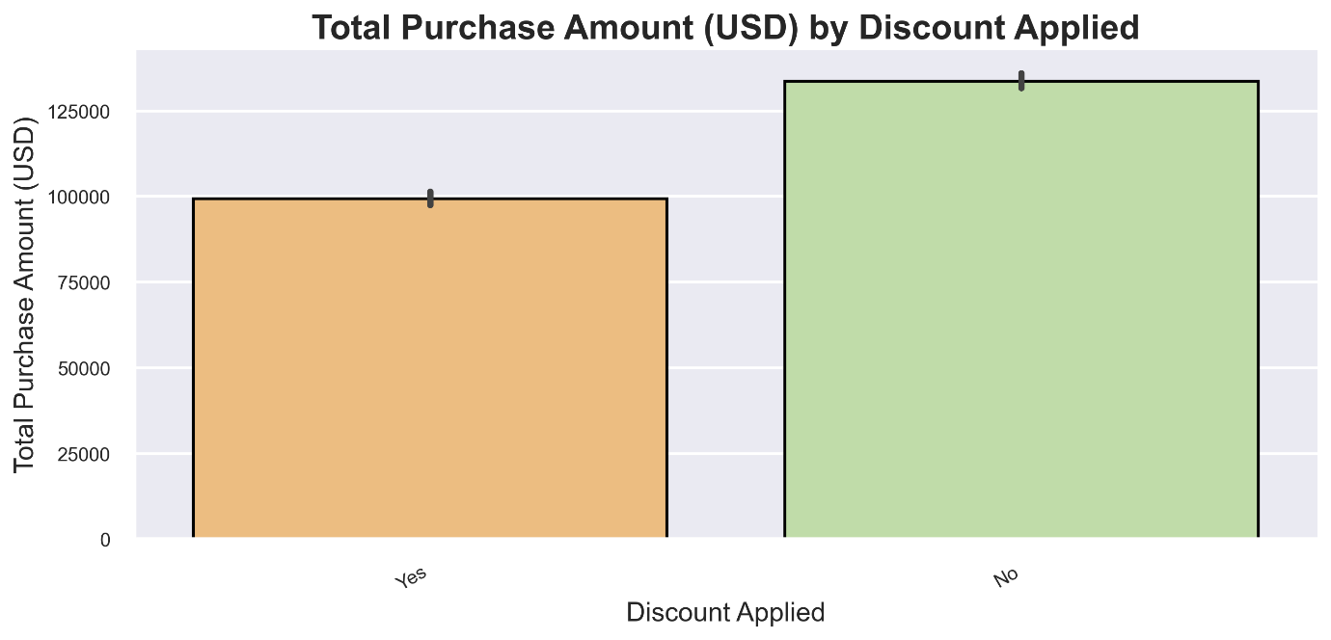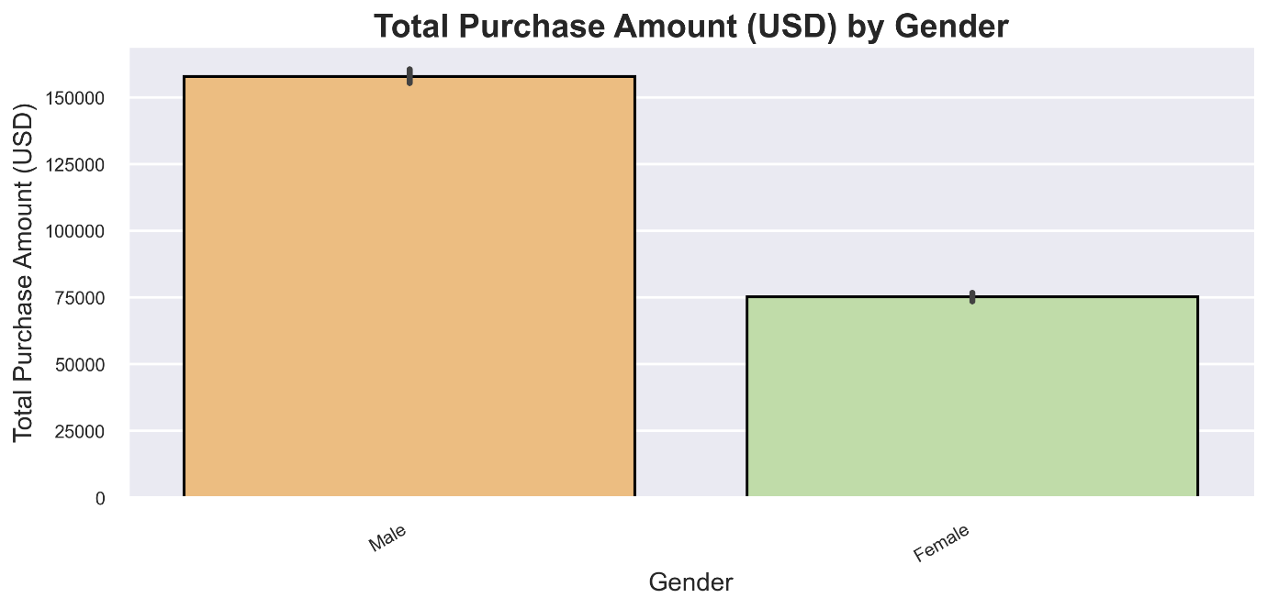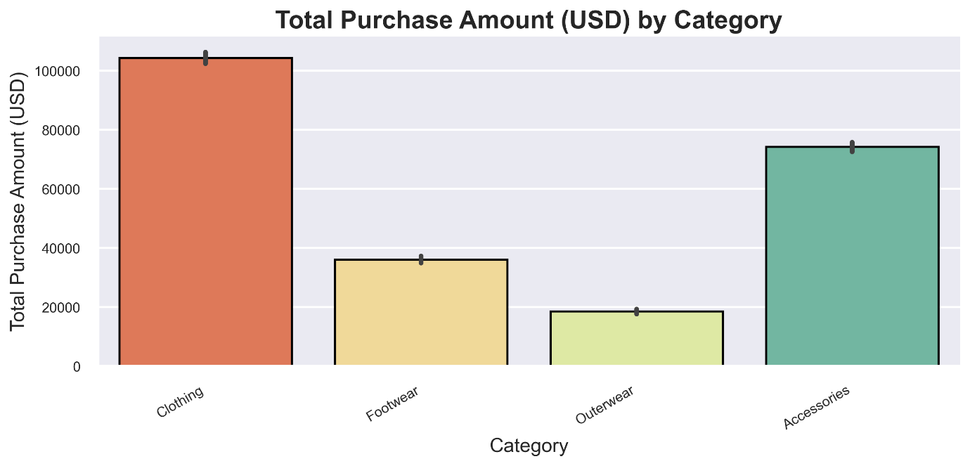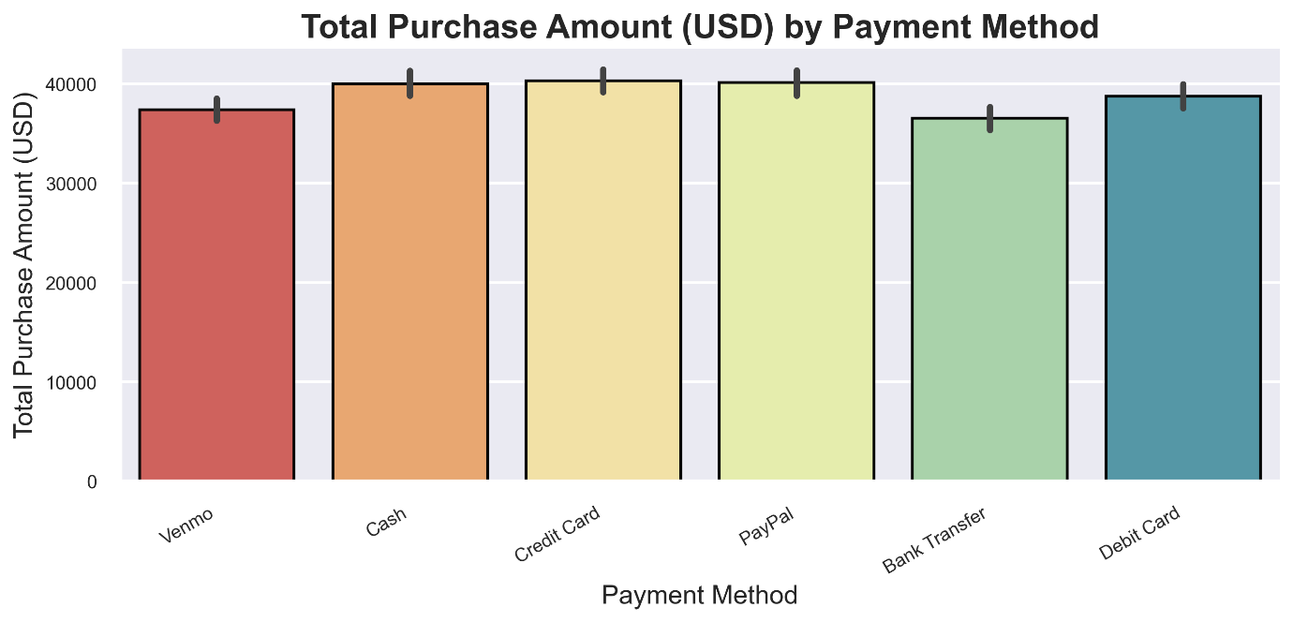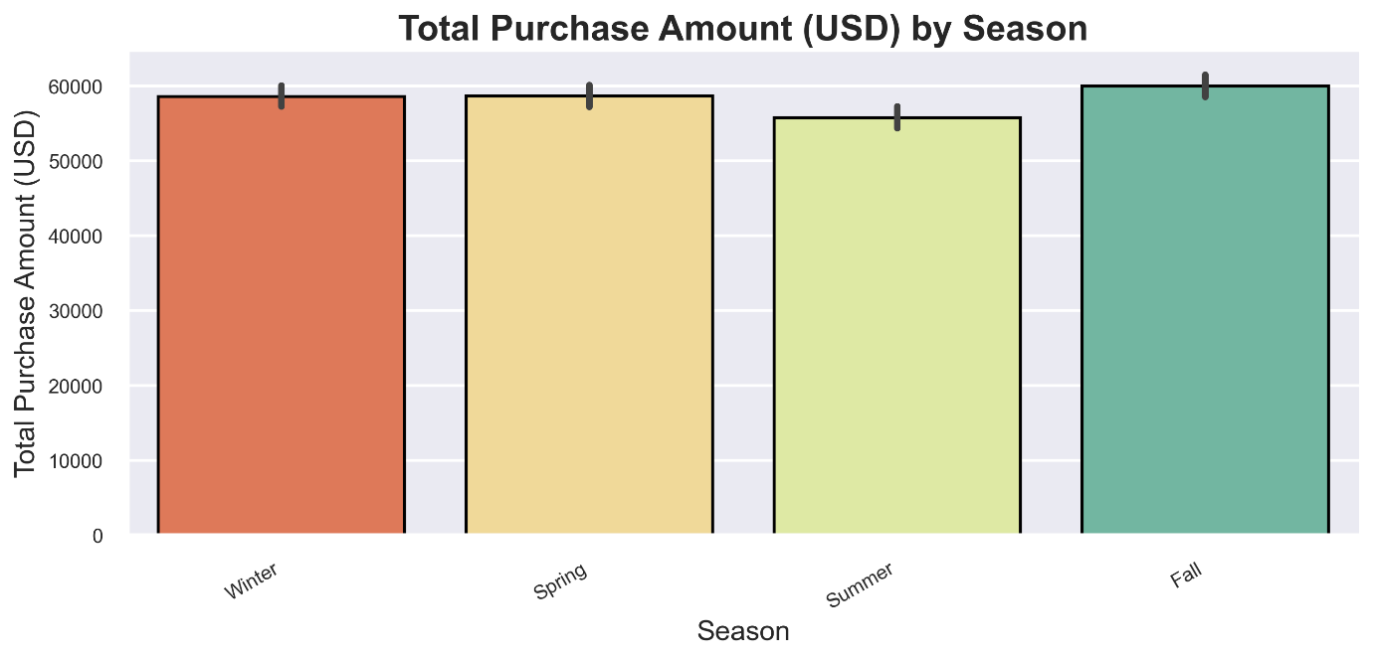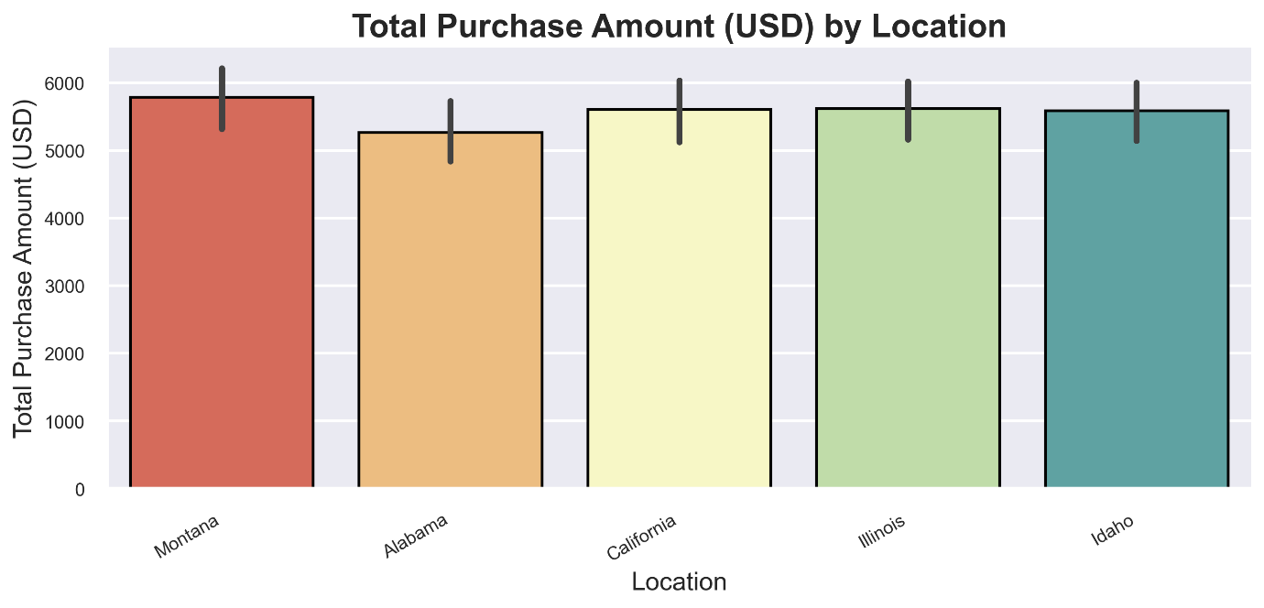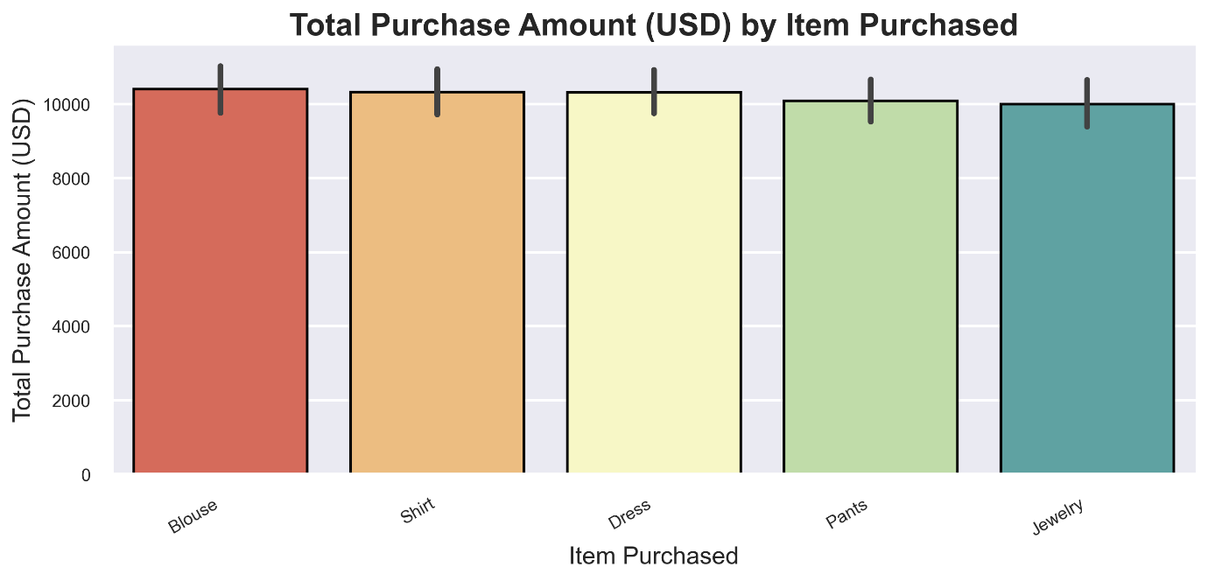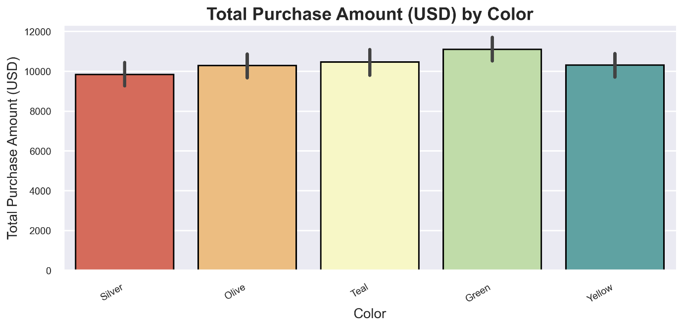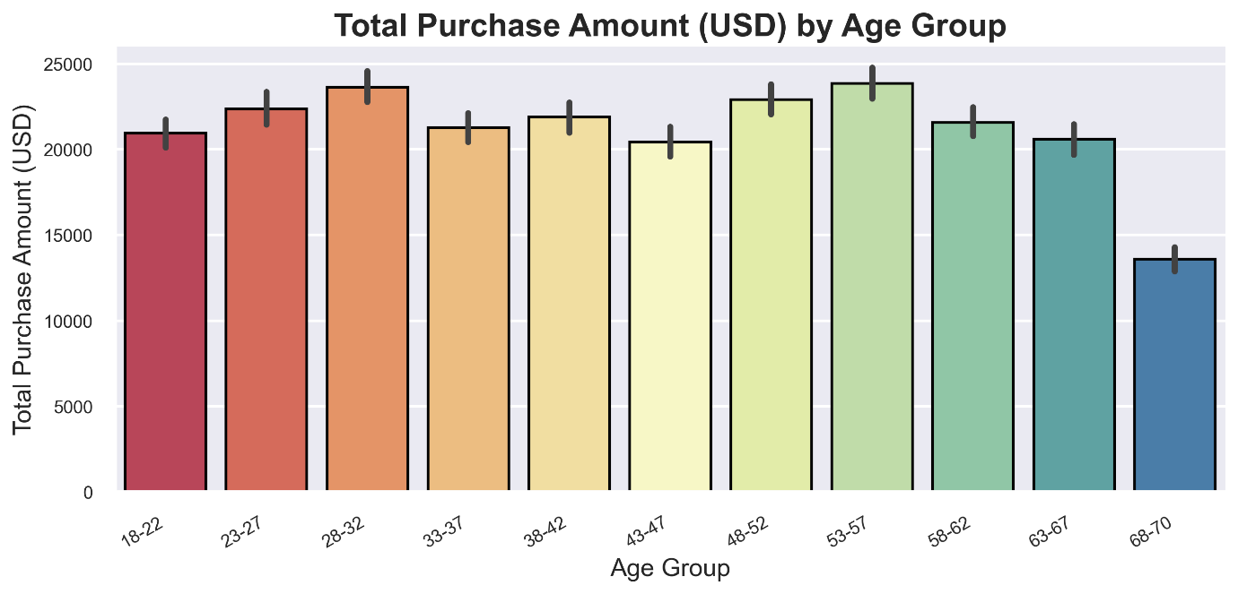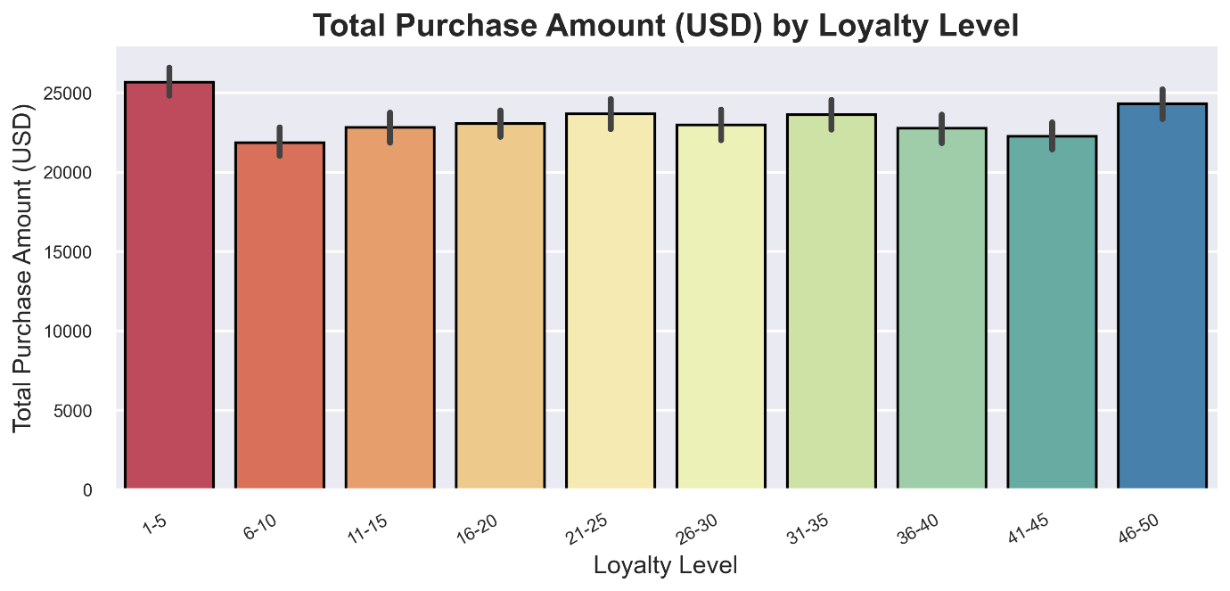

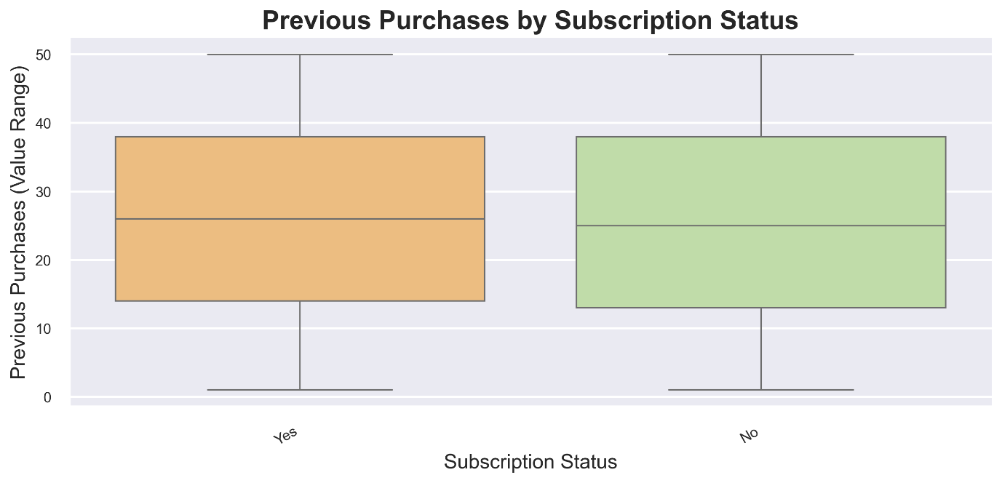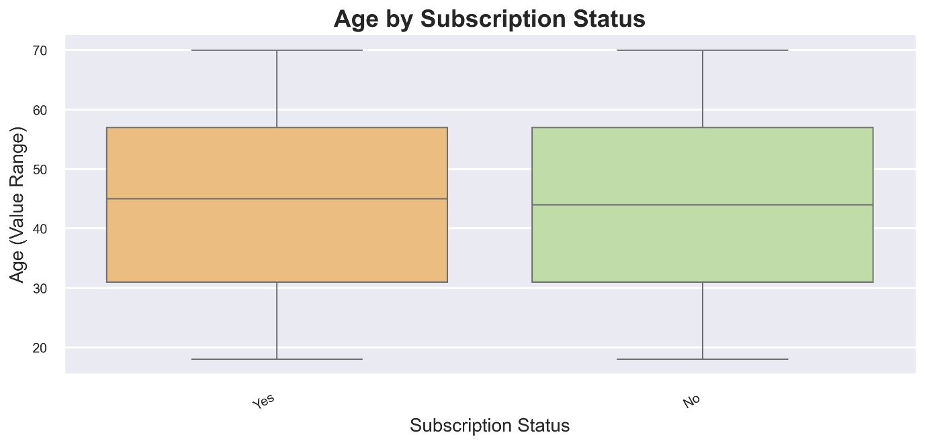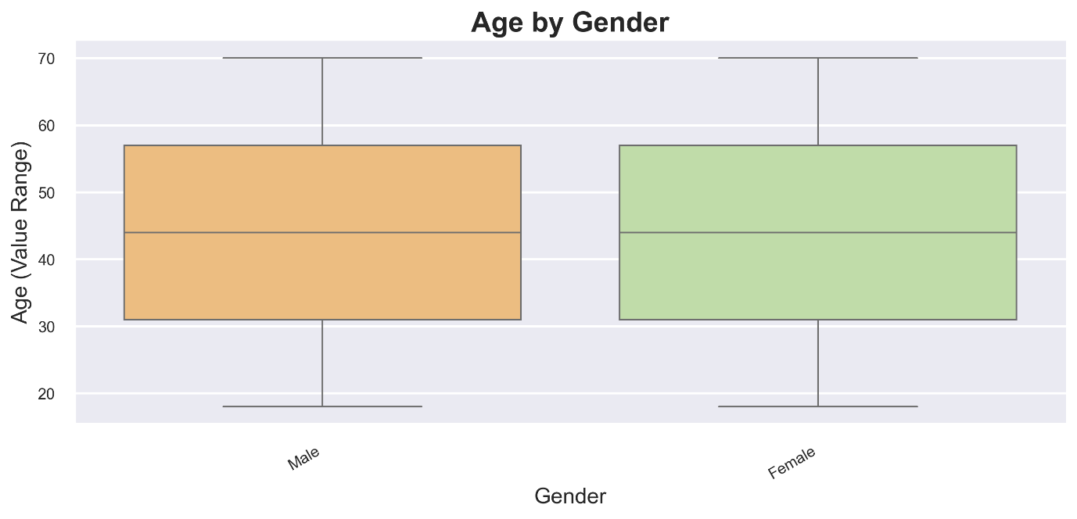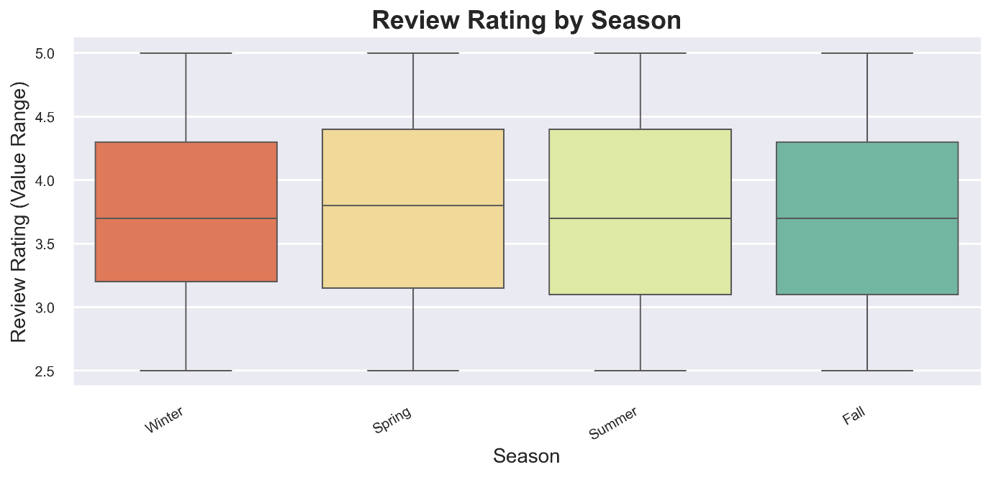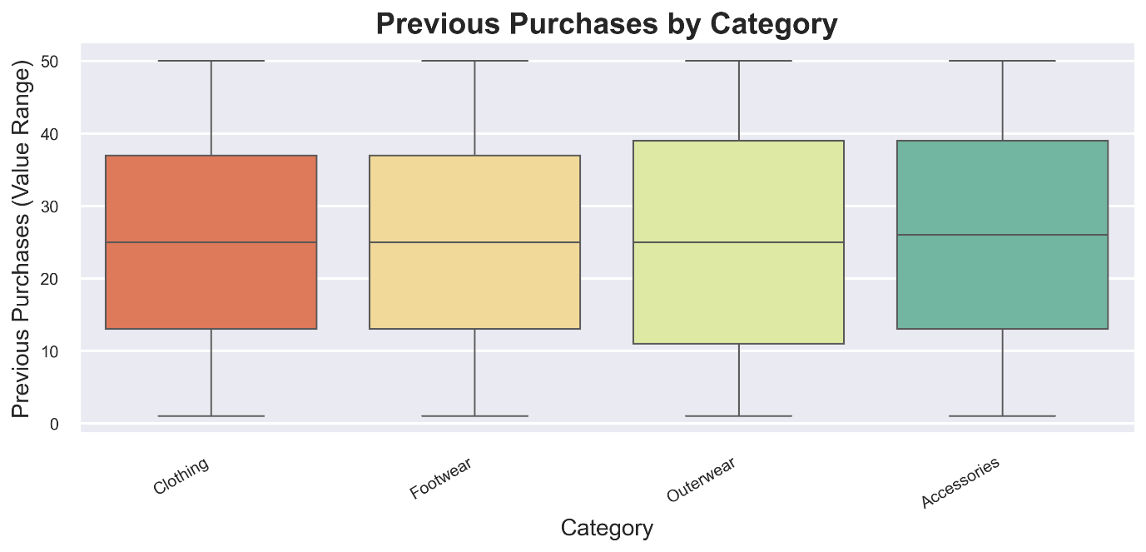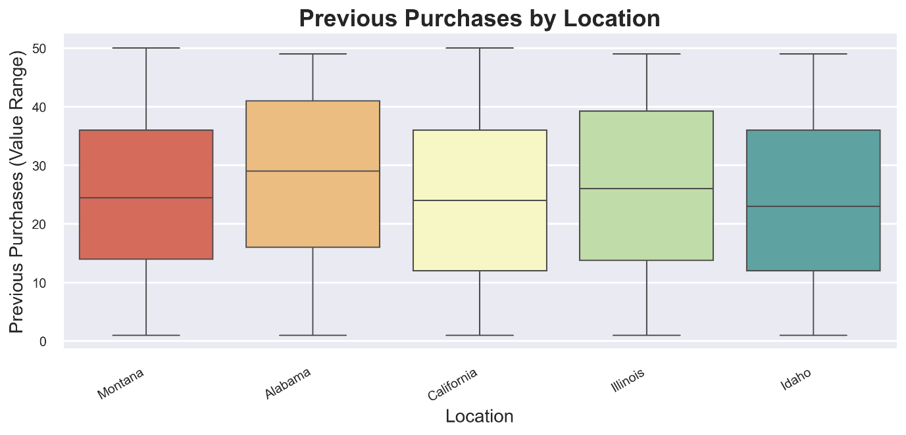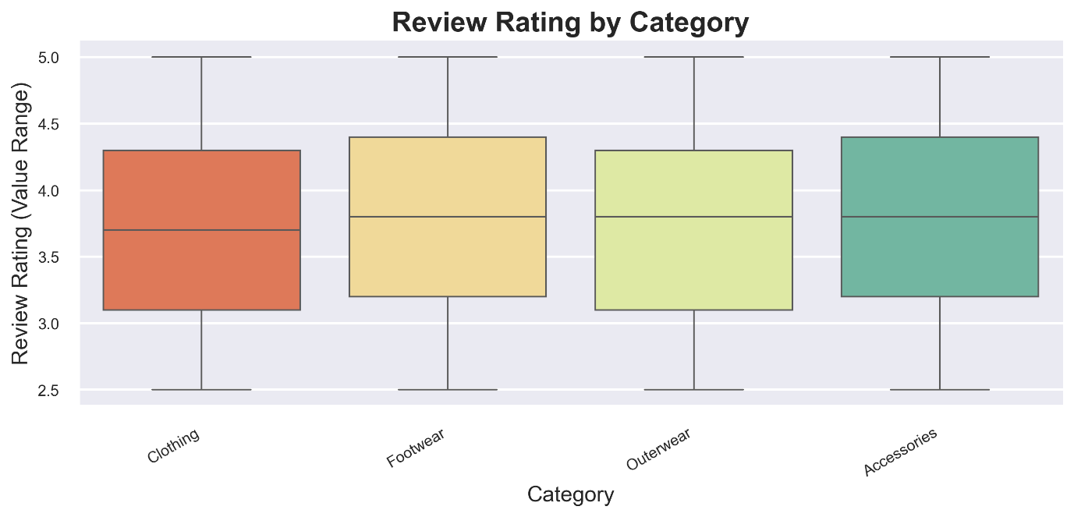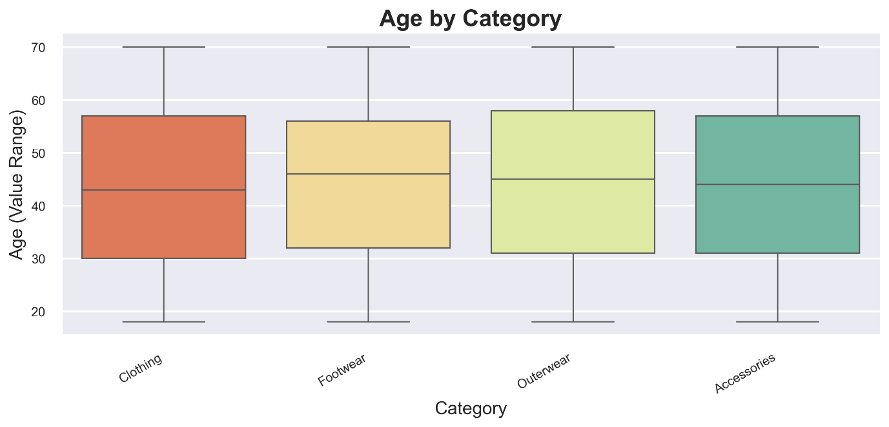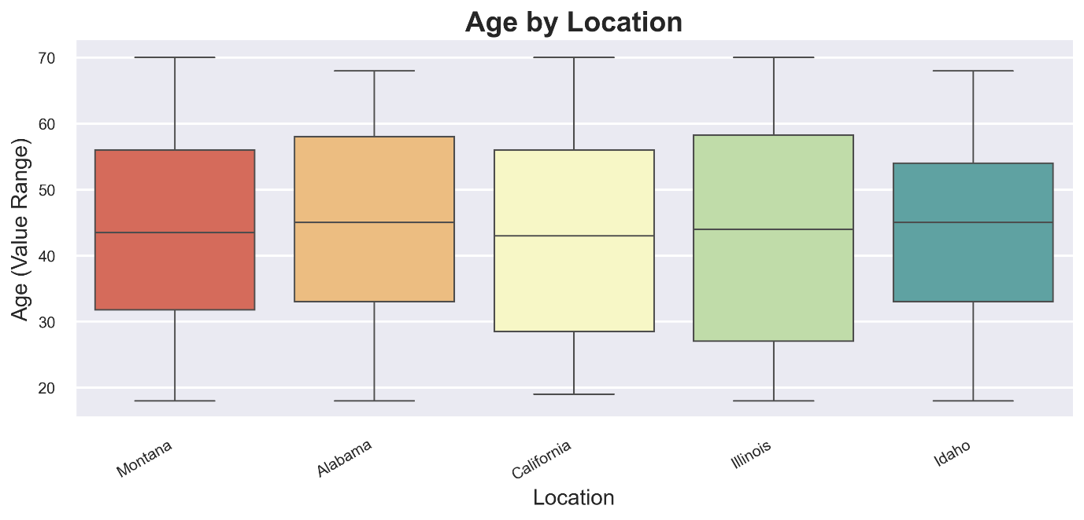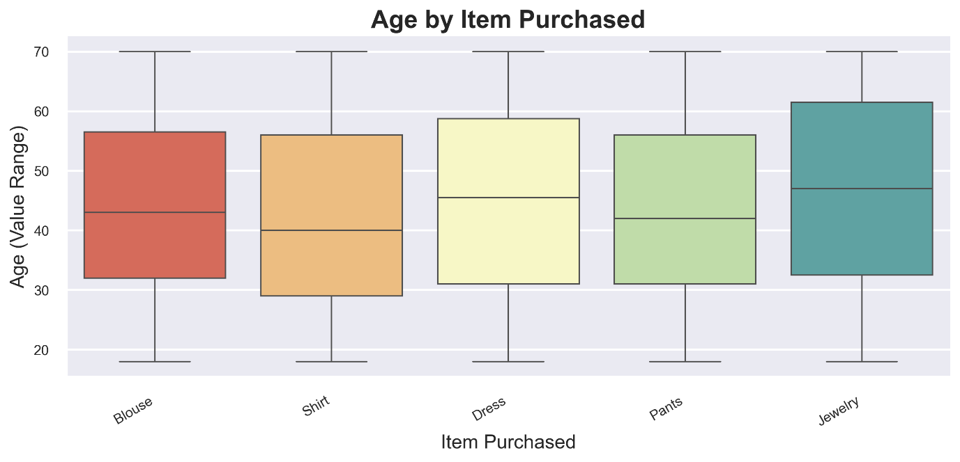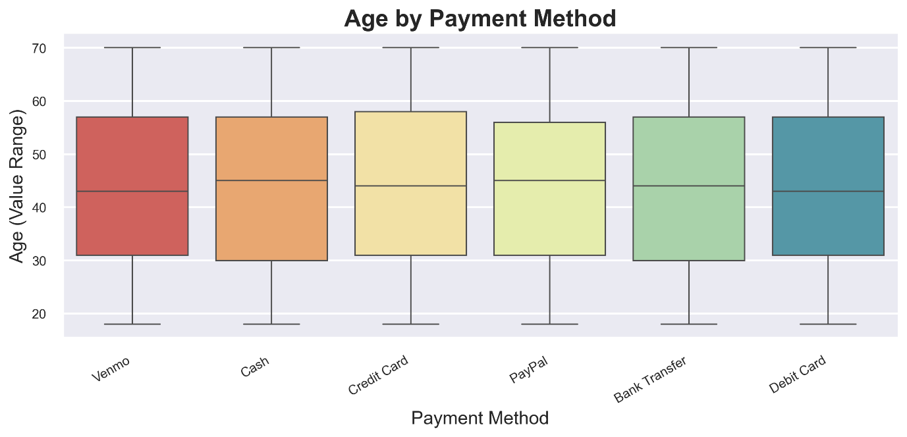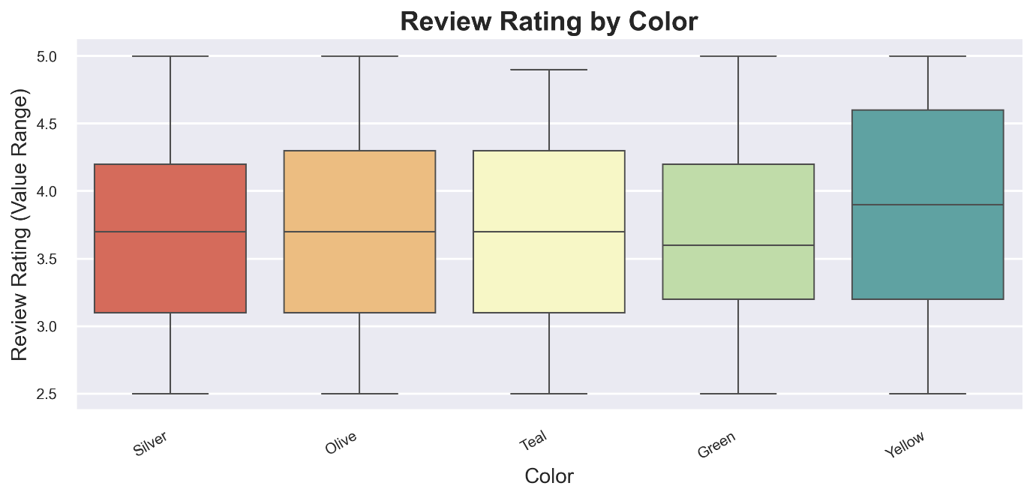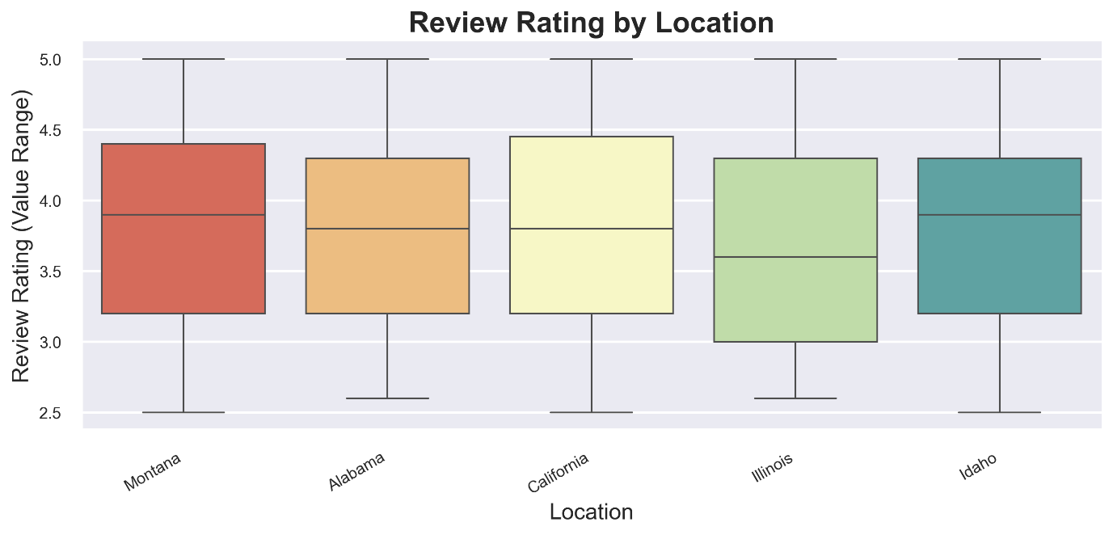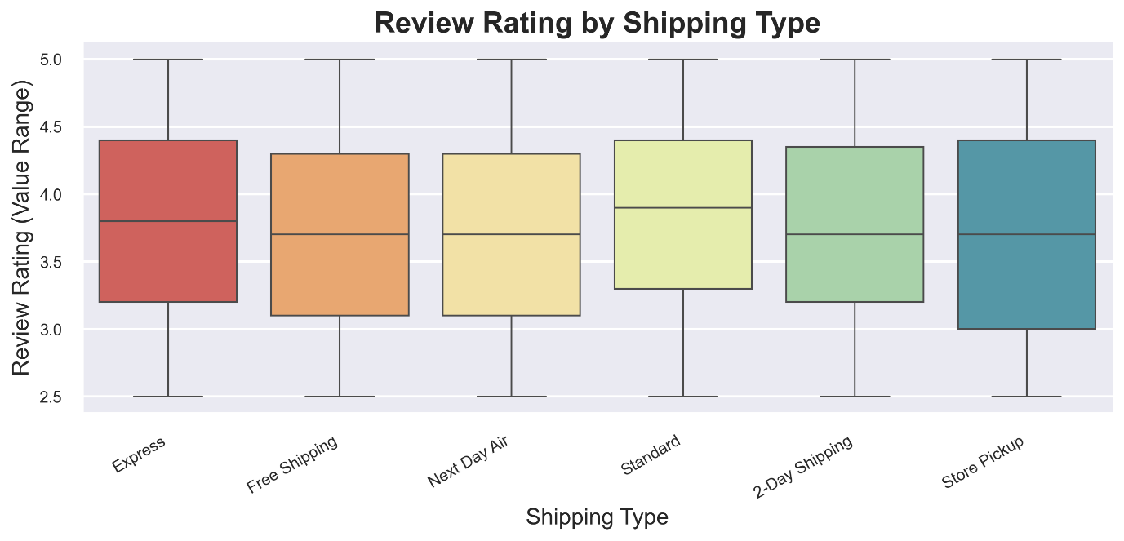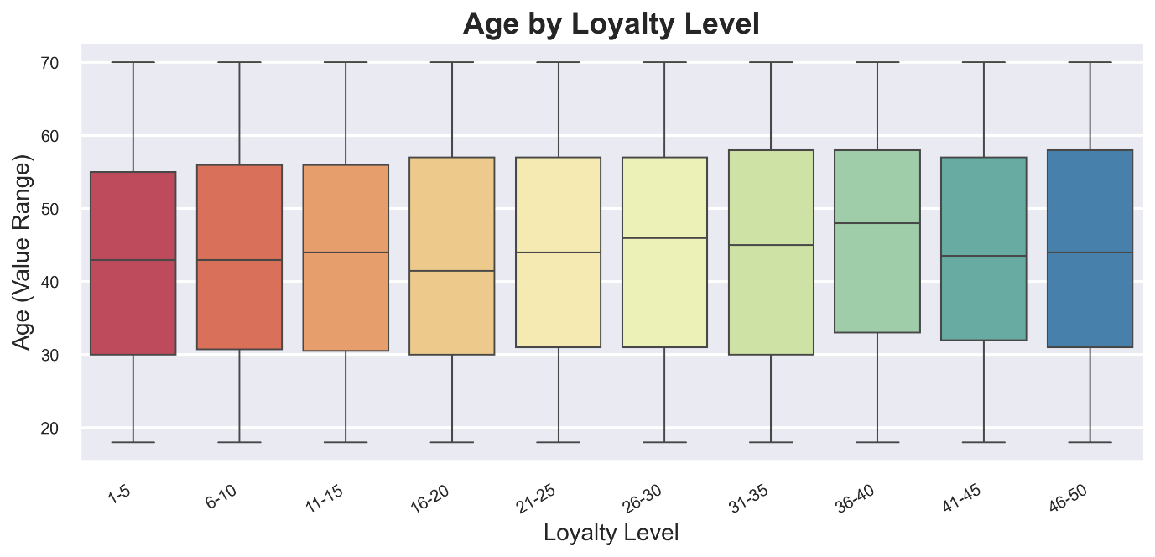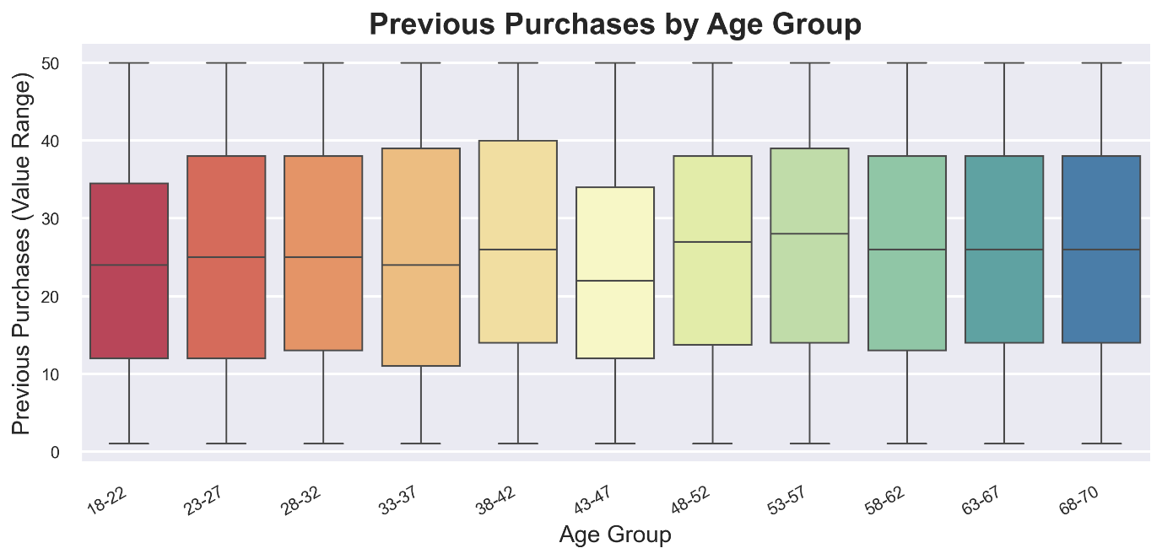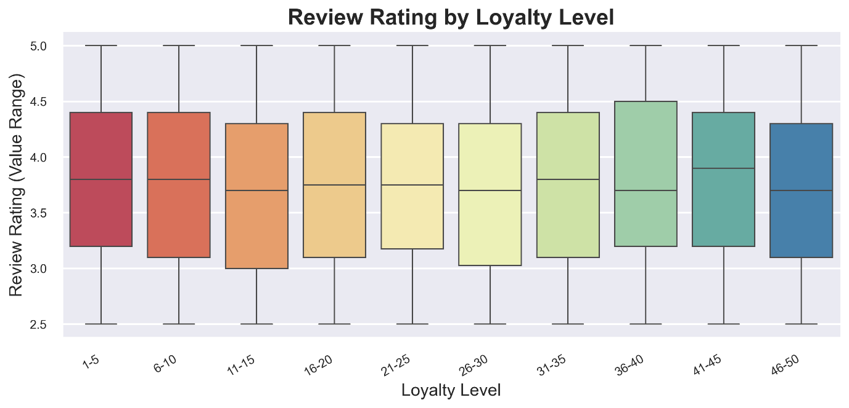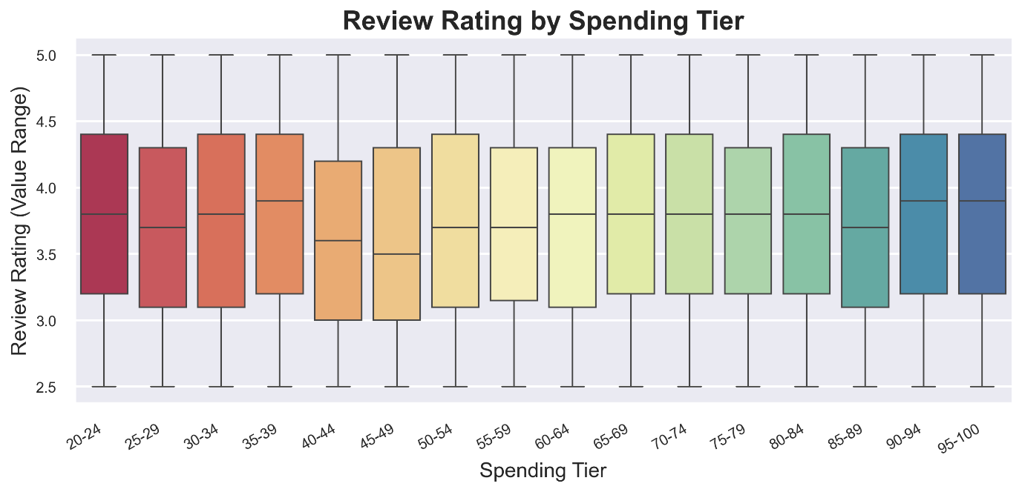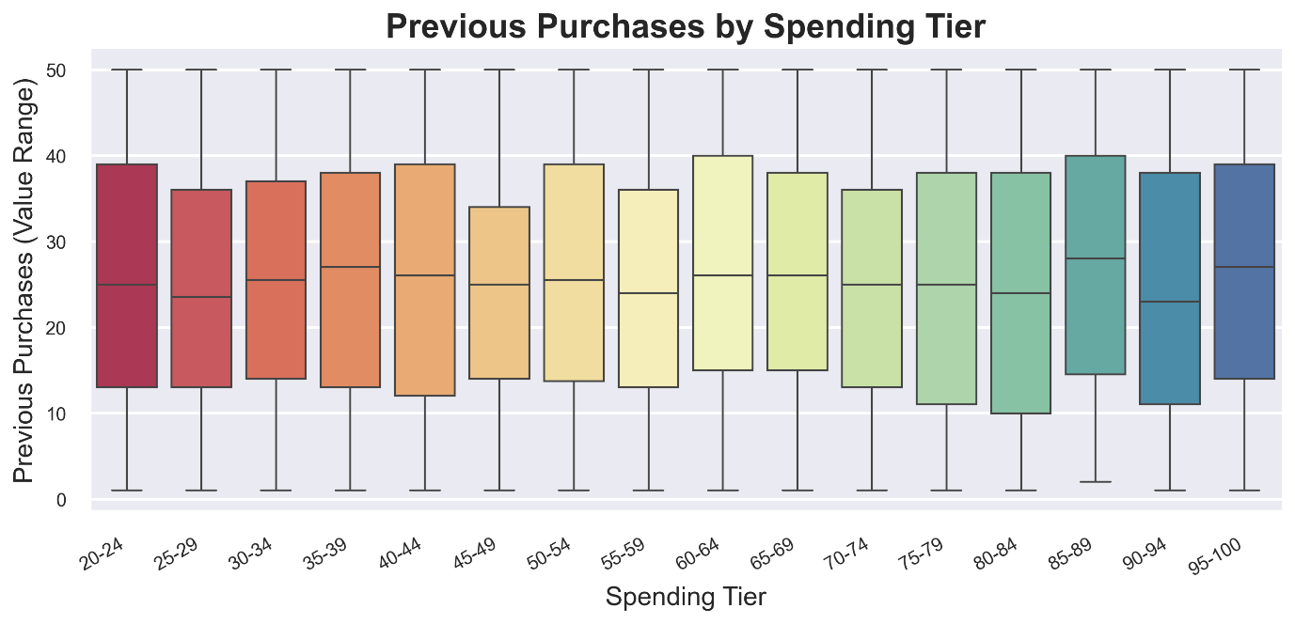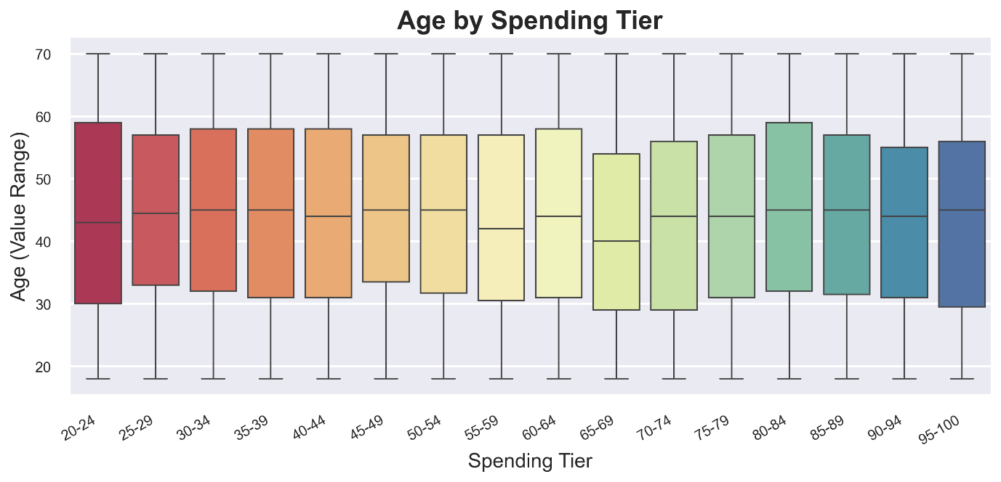

**Multivariate Analysis**

Age Group x Gender x Category

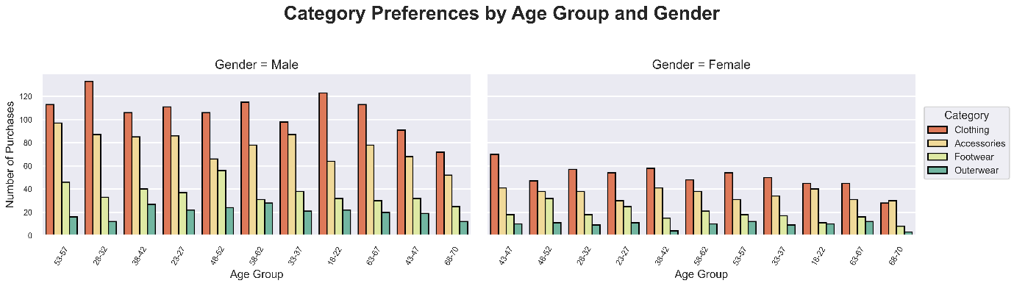

Age Group x Gender x Item Purchased

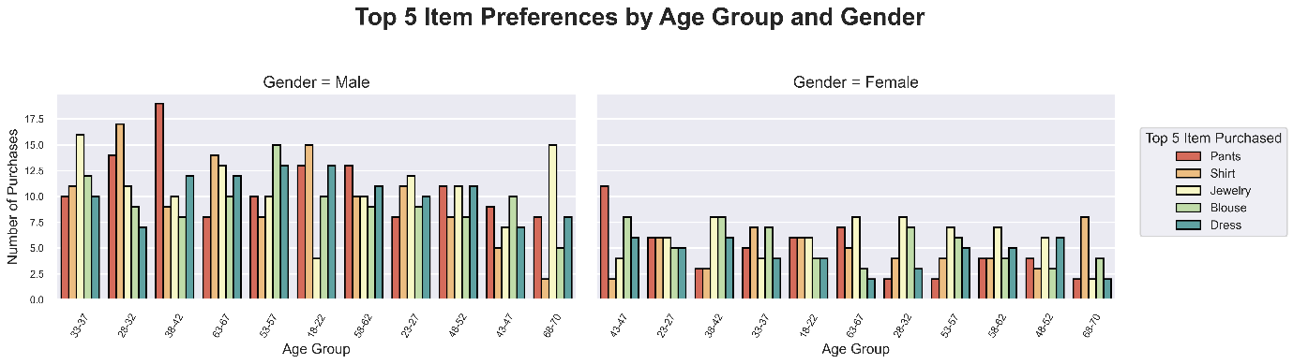

Age Group x Location x Category

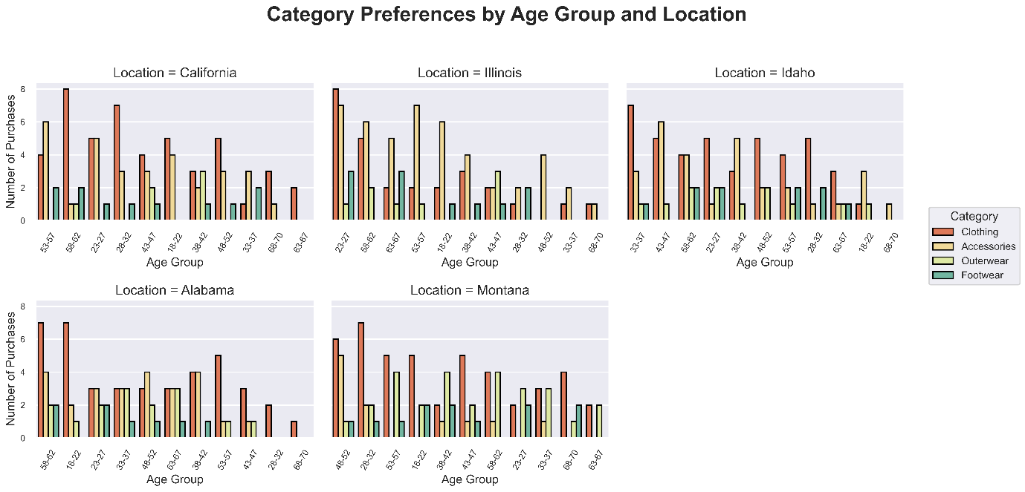

Age Group x Location x Item Purchased

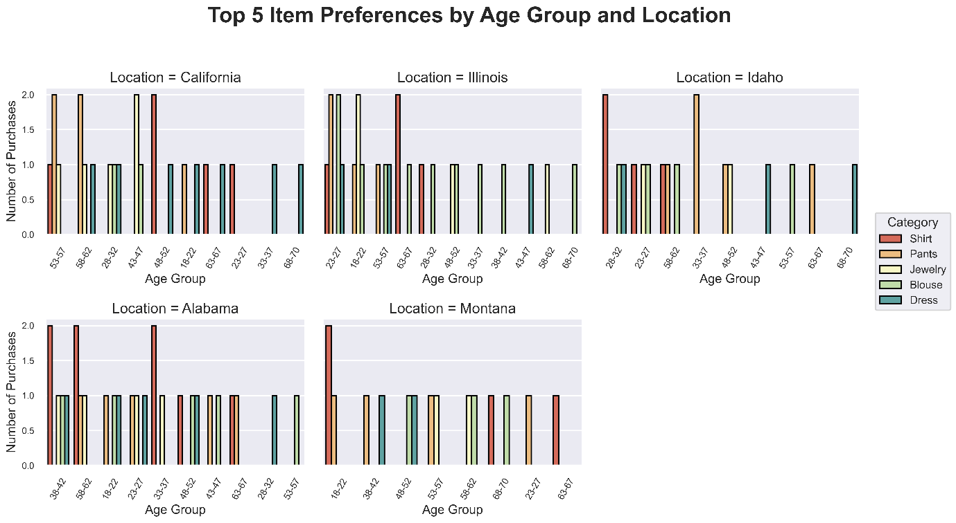

Age Group x Gender x Purchase Amount (USD)

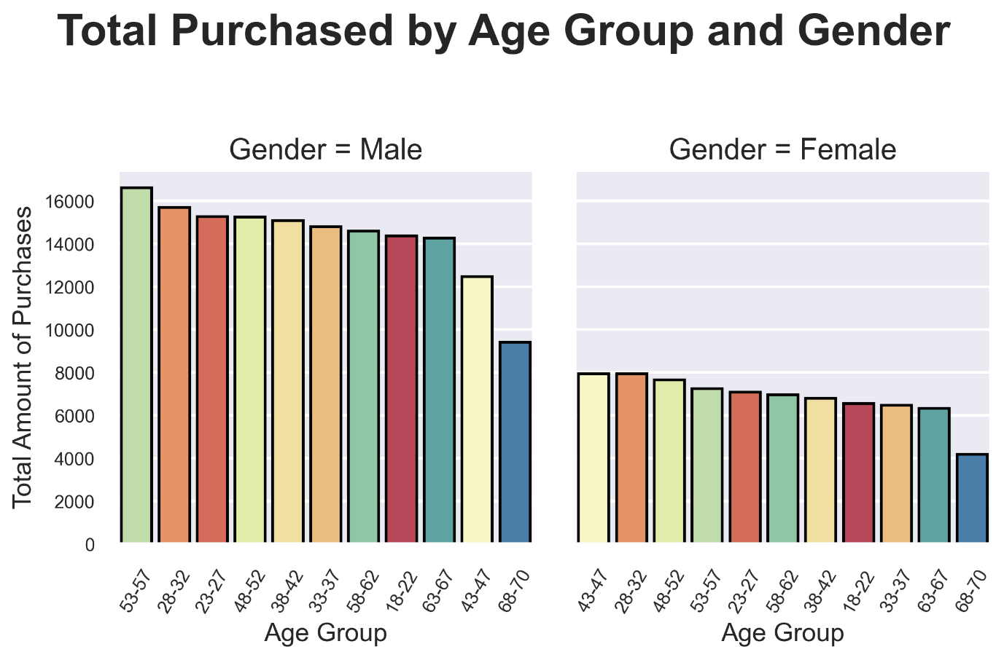

Age Group x Frequency of Purchases x Purchase Amount (USD)

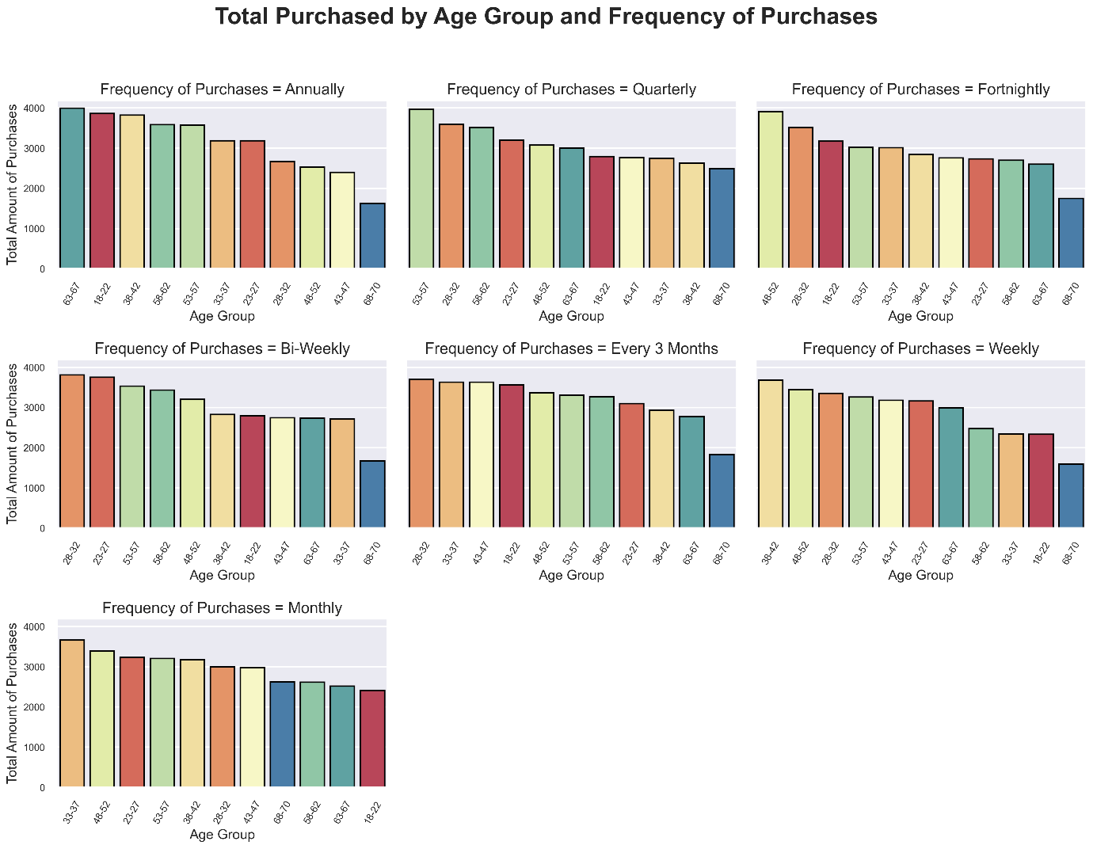

Discount Applied x Category x Purchased Amount

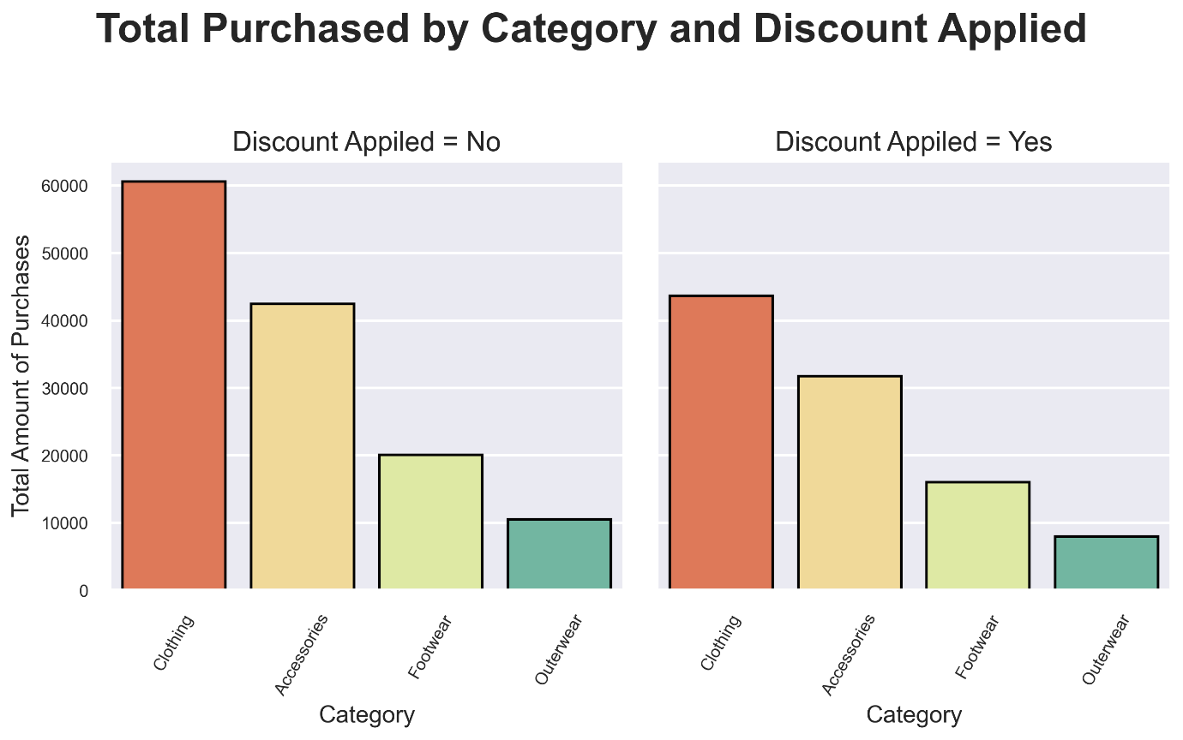

Promo Code Used x Gender x Purchase Amount

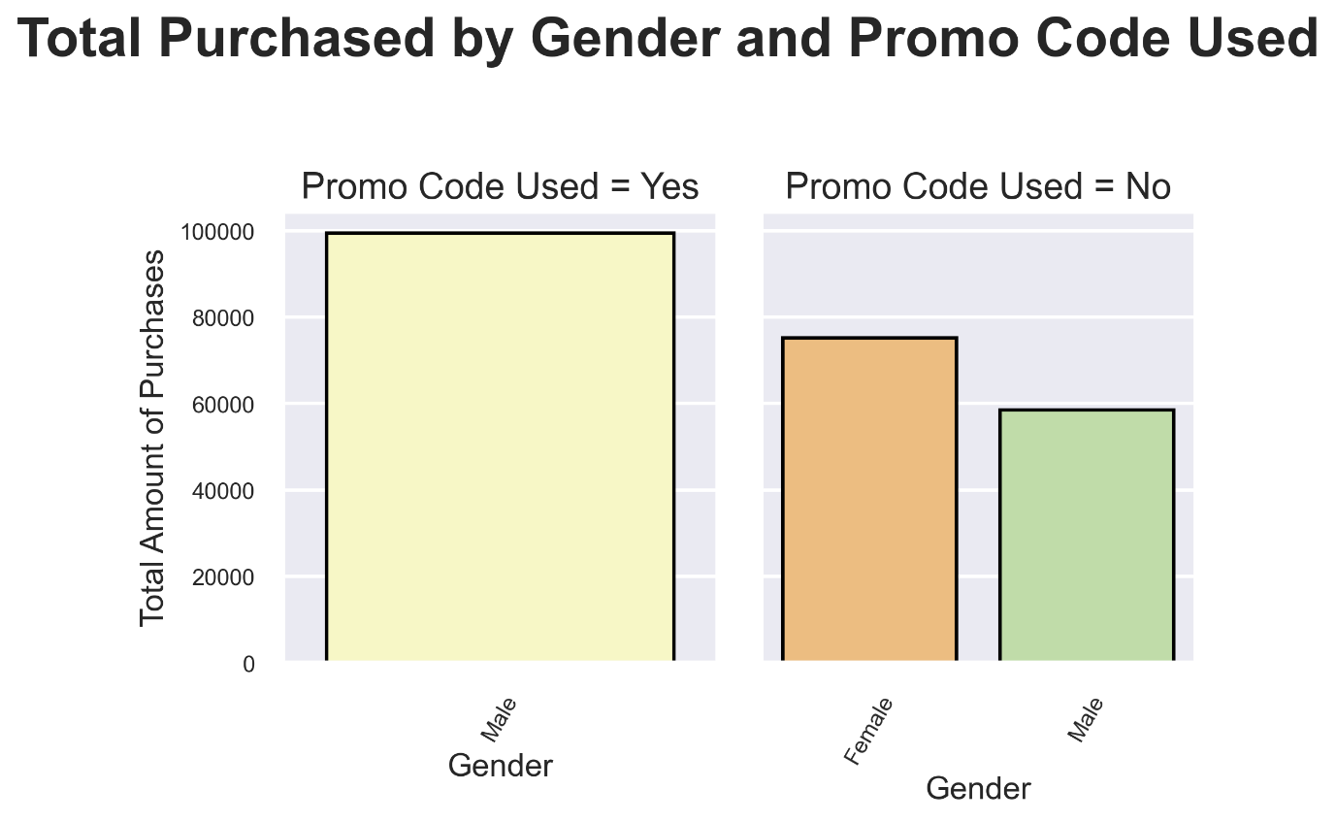

Season x Category x Purchase Amount (USD)

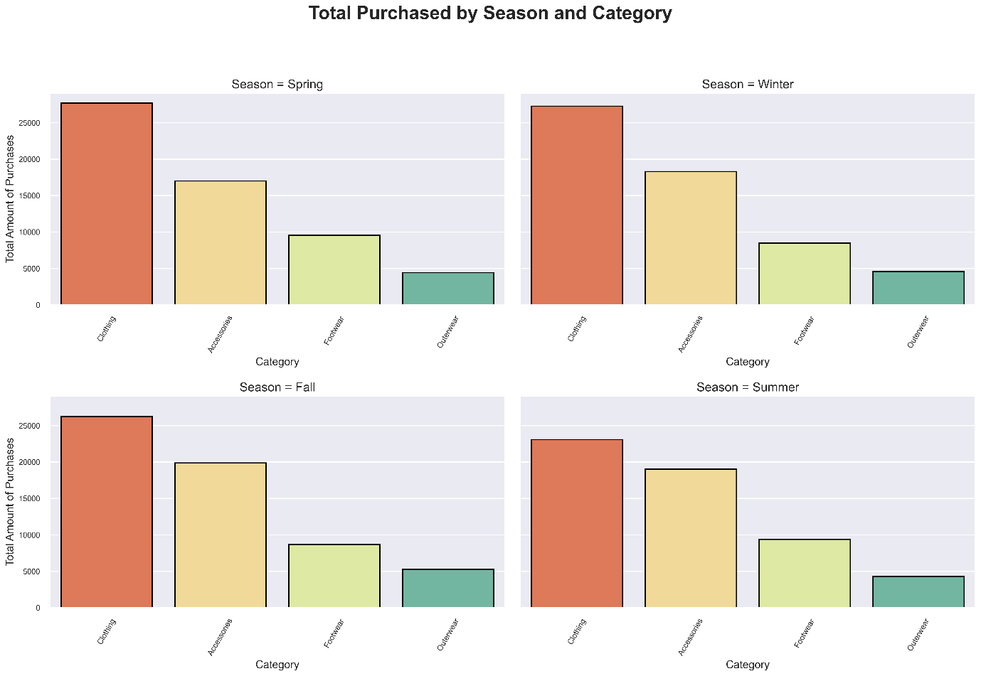

Season x Item Purchased x Purchase Amount

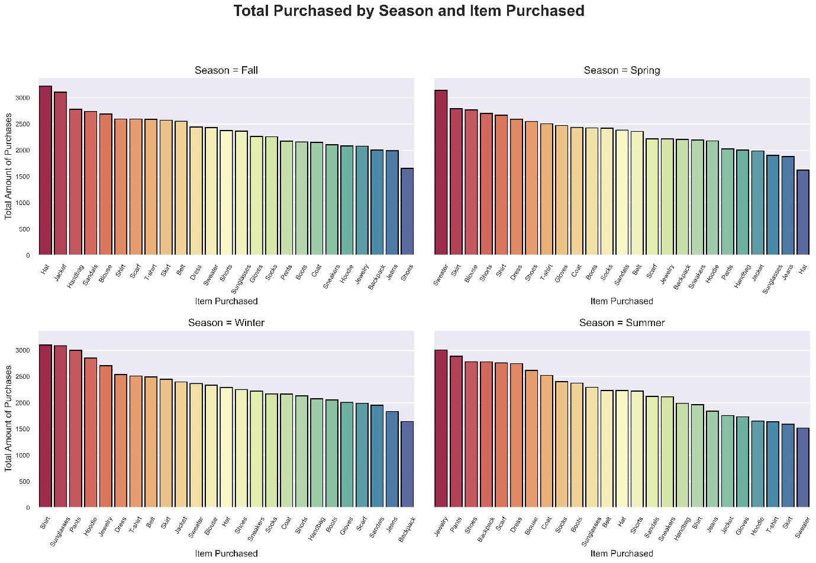

Color x Category x Purchase Amount

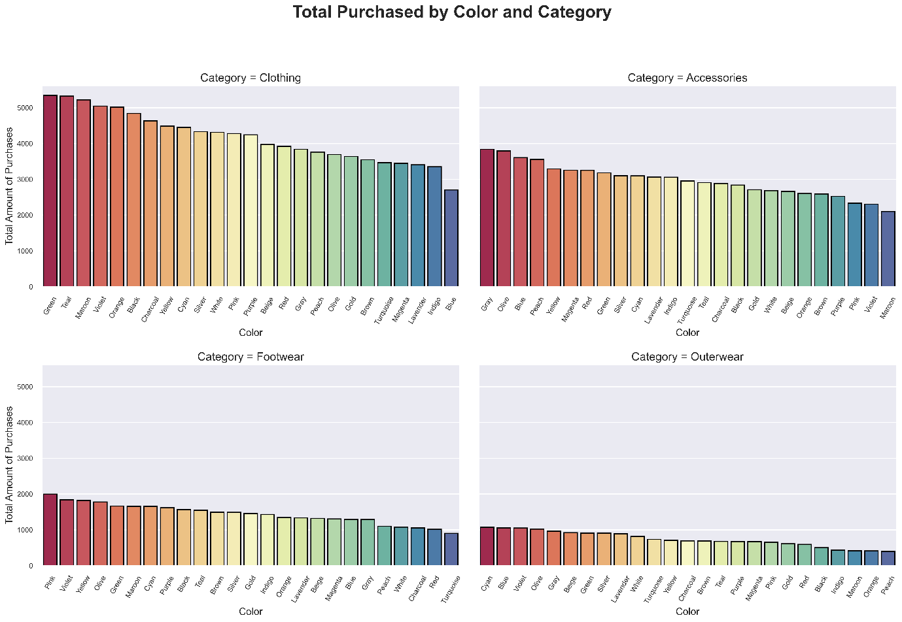

Subscription Status × Frequency of Purchases × Previous Purchases

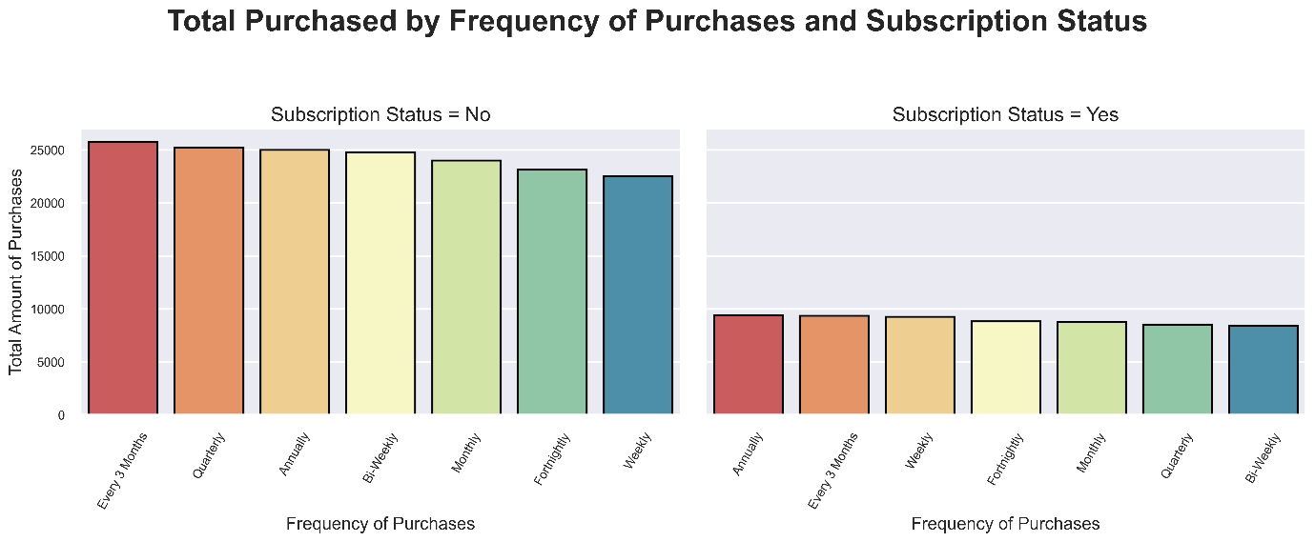

Review Rating × Category × Frequency of Purchases

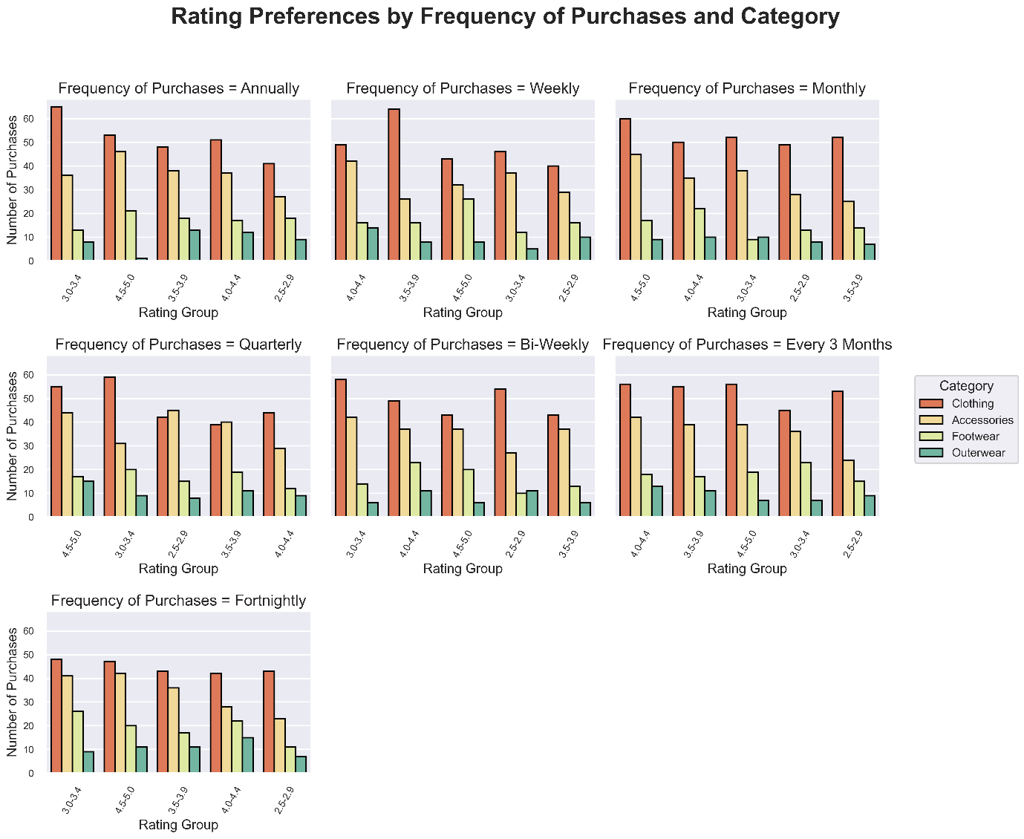

Location × Shipping Type × Purchase Amount

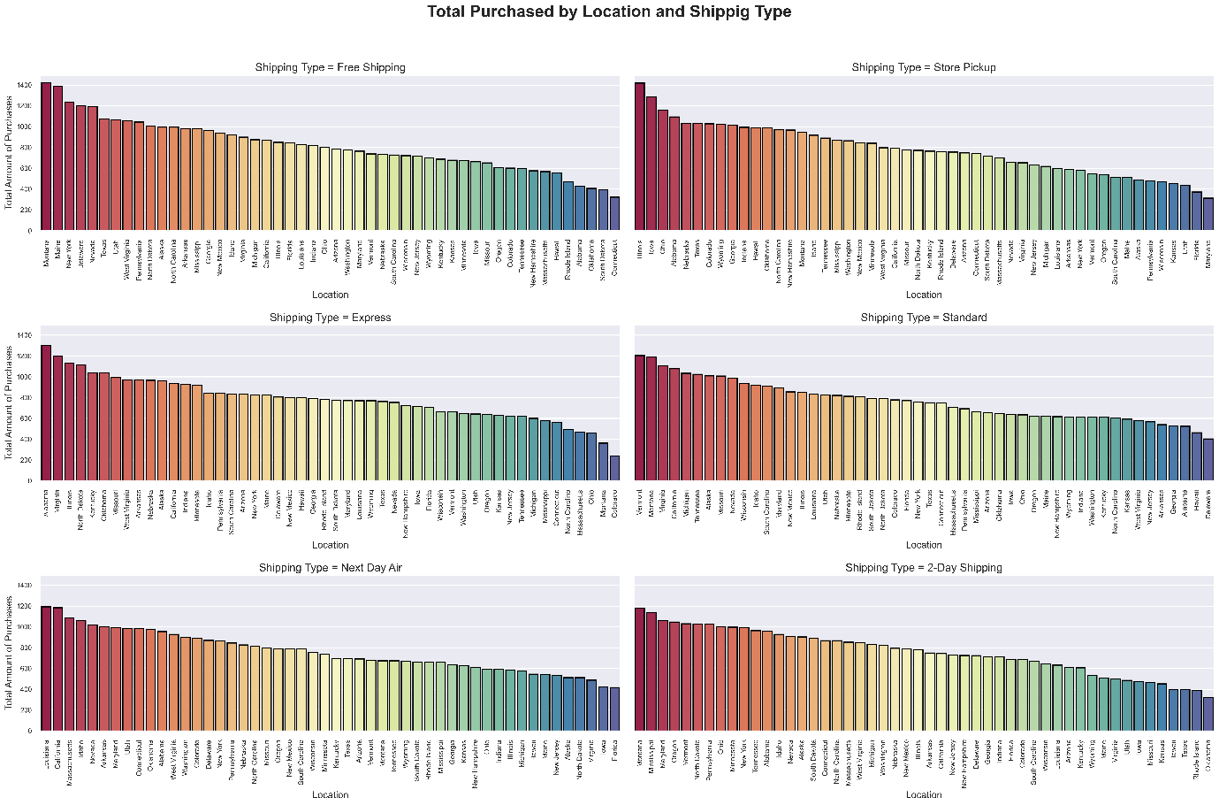

Payment Method × Category × Age Group

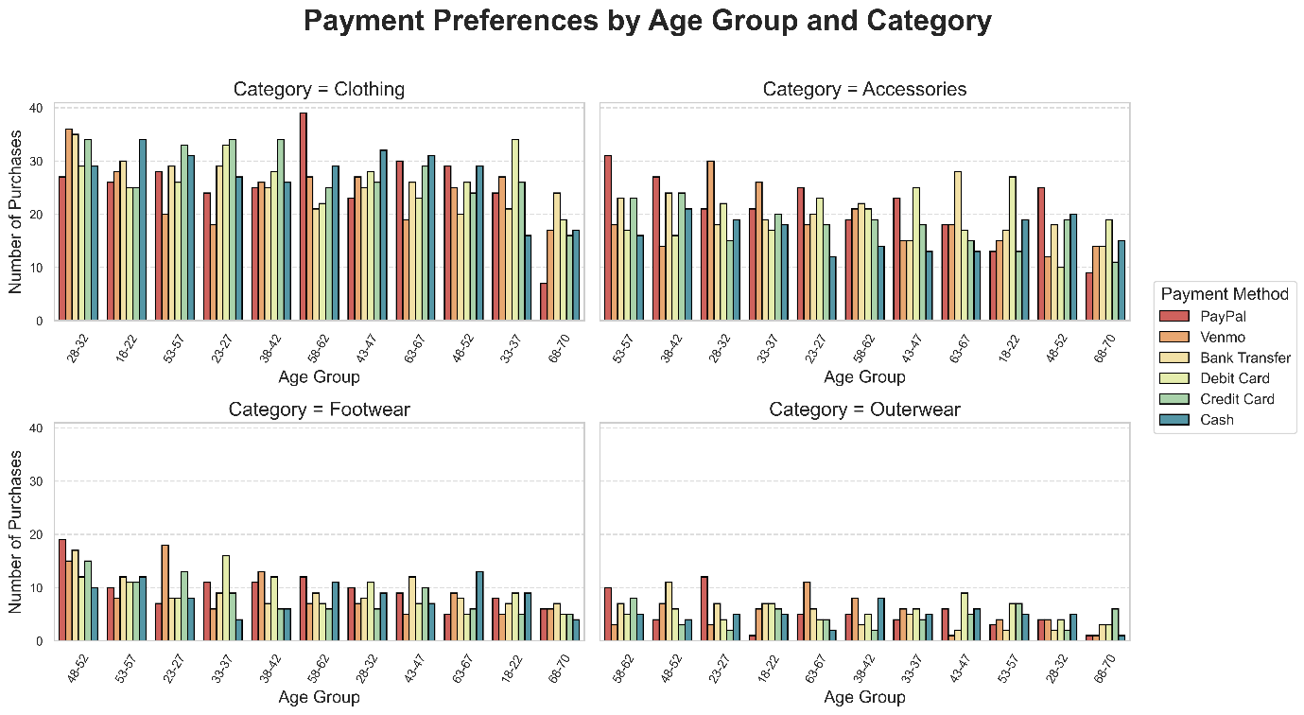

Age Group × Gender × Season × Category × Purchase Amount

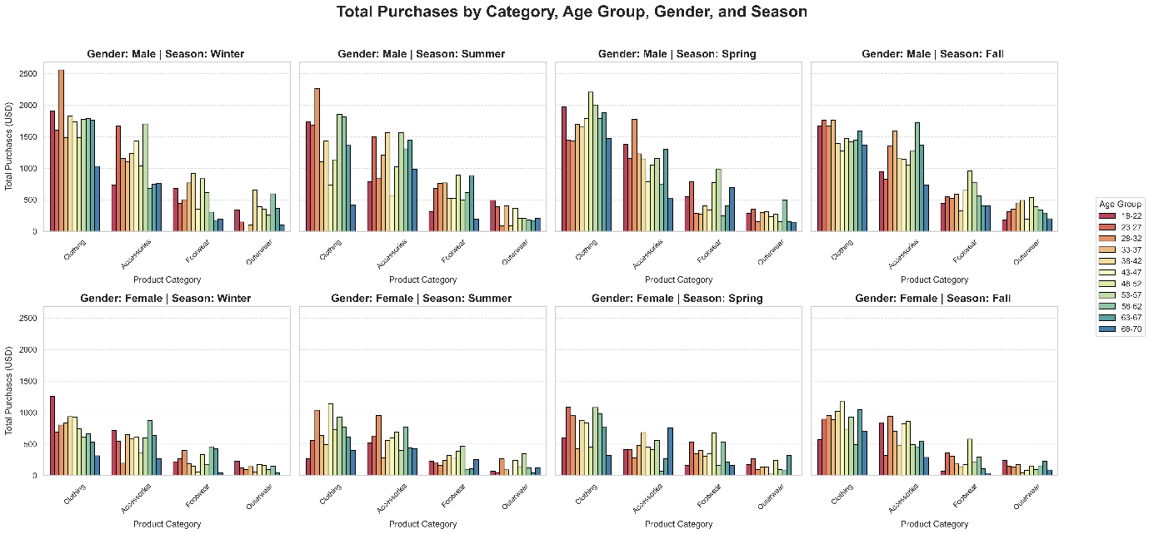

Payment Method × Subscription Status × Category × Purchase Amount × Frequency of Purchases

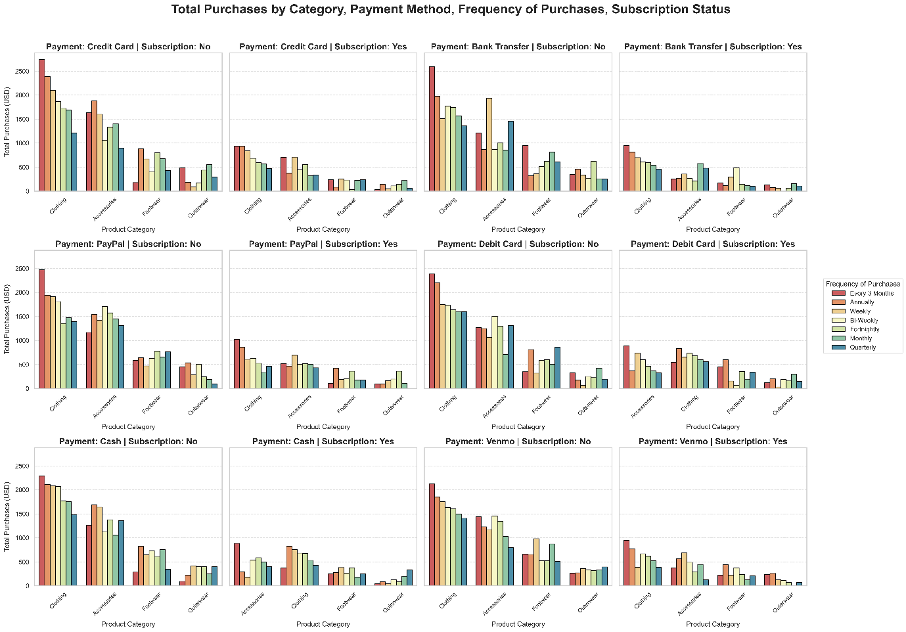

Location × Age Group × Discount Applied × Frequency of Purchases

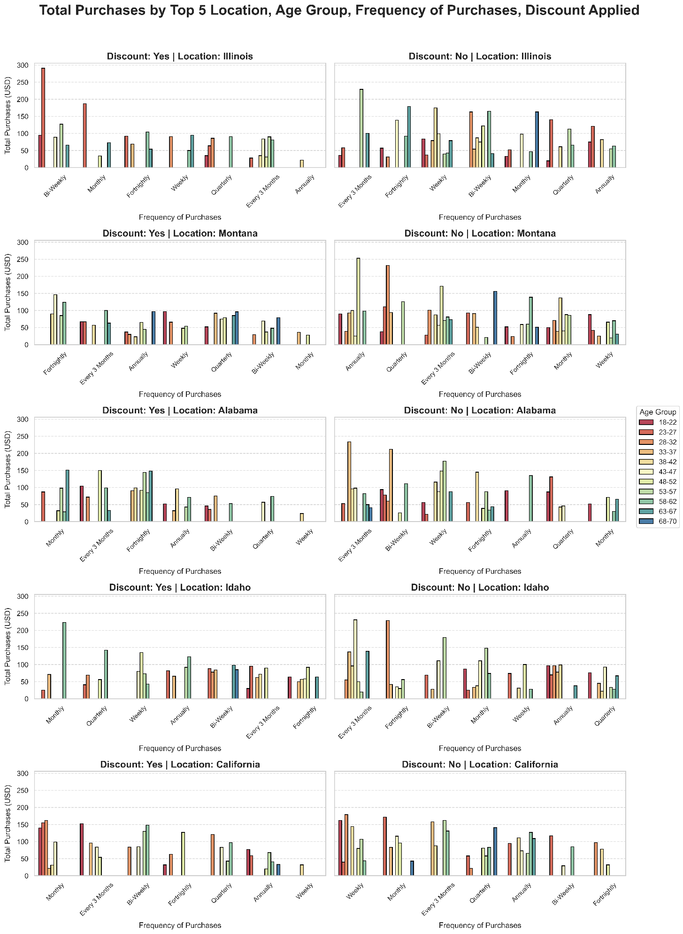

Age Group × Payment Method × Purchase Amount × Subscription Status × Review Rating

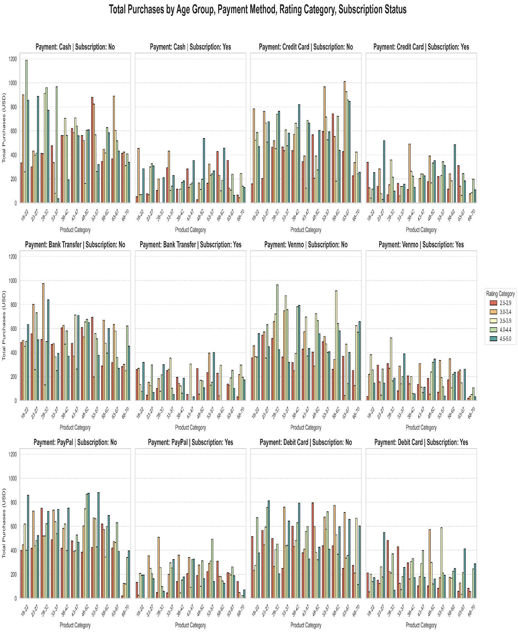

Season × Category × Discount Applied × Purchase Amount

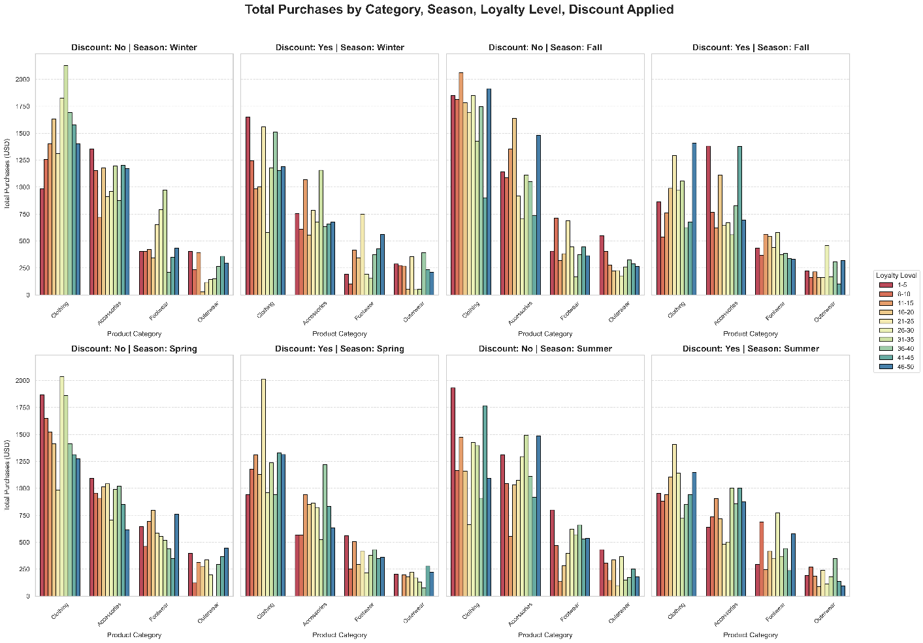

Category × Gender × Item Purchased × Purchase Amount

